MINOR PROJECT

On

**SOLAR**

***Submitted for the partial fulfillment for the requirements of the award***

***of***

***Bachelor of Computer Applications***

***By:-***

#### Jashan deep dhillon-(00628102021)

#### Sahil manav-(50128102021)

#### Nikhlesh kumar-(35228102021)

#### Gurjeet singh-(01396702021)

Under the guidance of

Mrs. Suma S



**KAMAL INSTITUTE OF HIGHER EDUCATION AND**

**ADVANCE TECHNOLOGY**

**(Affiliated to GGSIPU, Delhi) K-1**

**Extension, Mohan Garden**

**New Delhi- 110059**

## CERTIFICATE

This is to certify that the project report entitled **“SOLAR”** has been prepared by **Sahil manav , Jashan deep dhillon , Nikhlesh kumar , Gurjeet singh** under my supervision and guidance, for the fulfillment of Bachelors in Computer Application at Kamal Institute of Higher Education and Advanced Technology affiliated to Guru Gobind Singh Indraprastha University, Delhi during the year 2021-2024.

FACULTY INCHARGE DIRECTOR

(Mrs. Suma S). (Dr.AnudeepArora)

## ACKNOWLEDGMENT

I offer my sincere thanks and humble regards to **Kamal Institute of Higher Education and Advance Technology, Affiliated to Guru Gobind Singh Indraprasth University, New Delhi** for imparting us very valuable professional training in BCA.

I pay my gratitude and sincere regards to “**Mrs. Suma S.**” my project guide for giving me the cream of knowledge. I am thankful to her as she has been constant source of advice, motivation, inspiration and giving her suggestions and encouragement throughout the project.

I extend my sincere thanks to our respected Director **Dr. Anudeep Arora**, for allowing me to use the facilities available. I would like to thank other faculty members also, at this occasion and my Family too.

**Jashan deep dhillon- (00628102021)**

**Sahil manav- (50128102021)**

**Gurjeet singh- (01396702021)**

**Nikhlesh kumar- (35228102021)**

## DECLARATION

I do hereby declare that this project work entitled “**SOLAR**” ecommerce website submitted us me for the partial fulfillment of the requirement for the award of Bachelors in Computer Applications (BCA) is a record of our own research work. The report embodies the finding based on our study and observation and has not been submitted earlier for the award of any degree or diploma of any Institute or University.

**Date:**

**Sahil manav-(50128102021)**

**Gurjeet singh-(01396702021)**

**Nikhlesh kumar-(35228102021)**

**Jashan deep dhillon-(00628102021)**

## ABSTRACT

**SOLAR** is a Ecommerce website. The main purpose of this project is to sale the solar systems to the customers. Solar sale the solar system to help the environment and customers.. User can also give feedback about the product.. Database is created with the help of my sql.

This project is based on php and sql. The environment used for this project is the Visual Studio Code the development. This project is hosted on the local server.

## TABLE OF CONTENT

Certificate i

Acknowledgment ii

Declaration iii

Abstract iv

Chapter 1: Introduction 1-3

* 1. Project Objective 2
  2. Tools/Platforms 3

Chapter 2: Introduction to PHP… 4-16

1. PHP Introduction 5
   1. What is PHP File? 5
   2. What PHP can do? 5
   3. Why PHP? 5
   4. What’s new in PHP 7? 6
   5. Installation 6
   6. PHP Syntax 6
   7. PHP Variable 9

Chapter 3: System Analysis… 44-46

* 1. Software Requirement Specifications… 45
  2. Modules & Their Description 46

Chapter 4: System Design 47-49

* 1. Feasibility Study 48
  2. Data Flow Diagram 49

Chapter 5: System Implementation 50-85

* 1. Coding 51
  2. Working Screenshots… 82

Chapter 6: System Testing 86-87

* 1. Unit Testing 87
  2. Integration Testing 87

##### Chapter 7: Conclusion & Future Scope 88-89

**Chapter 8: Reference 90-91**

# Chapter 1 Introduction

## Introduction

The **SOLAR** is a ecommerce website and PHP based project. The main purpose of “Solar” is to sale the solar system to the customers.

### Project Objective

This application is developed to provide the best notes to the students. However, this is a free application no charges are applicable to read and download of the notes on this application. We have developed this app in search of notes at our time.

### Tools/Platforms

Hardware Required

|  |  |
| --- | --- |
| Processor | Intel i3 CPU 2.2GHZ |
| Motherboard | Intel 955 |
| Monitor | LED (1366 X 768) color |
| Hard Disk | SATA (1TB) or More |
| Cache Memory | 5 MB |
| Keyboard | Any (QWERTY) |
| Mouse | Any (Optical Mouse) |
| RAM | 4GB or More |

Software Required

|  |  |
| --- | --- |
| Operating System | Window 10 |
| Languages | HTML, CSS, JS, PHP, MySQL |
| Front End | HTML, CSS, JavaScript |
| Platform | VS code & Xampp |
| Database | PHPMyAdmin & MySQL |

# Chapter 2

## Introduction to PHP

PHP code is executed on the server. PHP is an acronym for "PHP: Hypertext Preprocessor". PHP is a widely-used, open source scripting language. PHP scripts are executed on the server. PHP is free to download and use.

**PHP is an amazing and popular language!**

It is powerful enough to be at the core of the biggest blogging system on the web (WordPress)! It is deep enough to run large social networks! It is also easy enough to be a beginner's first server side language!

* 1. **What is a PHP File?**

PHP files can contain text, HTML, CSS, JavaScript, and PHP code. PHP code is executed on the server, and the result is returned to the browser as plain HTML. PHP files have extension ".php".

#### What Can PHP Do?

* + - PHP can generate dynamic page content
    - PHP can create, open, read, write, delete, and close files on the server
    - PHP can collect form data
    - PHP can send and receive cookies
    - PHP can add, delete, modify data in your database
    - PHP can be used to control user-access
    - PHP can encrypt data

With PHP you are not limited to output HTML. You can output images, PDF files, and even Flash movies. You can also output any text, such as XHTML and XML.

#### Why PHP?

* + - PHP runs on various platforms (Windows, Linux, Unix, Mac OS X, etc.)
    - PHP is compatible with almost all servers used today (Apache, IIS, etc.)
    - PHP supports a wide range of databases
    - PHP is free. Download it from the official PHP resource: [www.php.net](http://www.php.net/)
    - PHP is easy to learn and runs efficiently on the server side

#### What's new in PHP 7?

* + - PHP 7 is much faster than the previous popular stable release (PHP 5.6)
    - PHP 7 has improved Error Handling
    - PHP 7 supports stricter Type Declarations for function arguments
    - PHP 7 supports new operators (like the spaceship operator: <=>)

#### PHP Installation

* + 1. What Do I Need?

To start using PHP, you can:

* + - * Find a web host with PHP and MySQL support
      * Install a web server on your own PC, and then install PHP and MySQL
    1. Use a Web Host with PHP Support

If your server has activated support for PHP you do not need to do anything. Just create some .php files, place them in your web directory, and the server will automatically parse them for you. You do not need to compile anything or install any extra tools. Because PHP is free, most web hosts offer PHP support.

* + 1. Set up PHP on Your Own PC

However, if your server does not support PHP, you must:

* + - * install a web server
      * install PHP
      * install a database, such as MySQL

The official PHP website (PHP.net) has installation instructions for PHP: <http://php.net/manual/en/install.php>

#### PHP Syntax

A PHP script is executed on the server, and the plain HTML result is sent back to the browser.

* + 1. Basic PHP Syntax

A PHP script can be placed anywhere in the document. A PHP script starts with <?php and ends with ?>:

<?php

// PHP code goes here

?>

The default file extension for PHP files is ".php".

A PHP file normally contains HTML tags, and some PHP scripting code.

Below, we have an example of a simple PHP file, with a PHP script that uses a built-in PHP function "echo" to output the text "Hello World!" on a web page:

* + - 1. Example

<!DOCTYPE html>

<html>

<body>

<h1>My first PHP page</h1>

<?php

echo "Hello World!";

?>

</body>

</html>

* + 1. PHP Case Sensitivity

In PHP, keywords (e.g. if, else, while, echo, etc.), classes, functions, and user- defined functions are not case-sensitive.

In the example below, all three echo statements below are equal and legal:

* + - 1. Example

**Note:** However; all variable names are case-sensitive!

<!DOCTYPE html>

<html>

<body>

<?php

ECHO "Hello World!<br>"; echo "Hello World!<br>"; EcHo "Hello World!<br>";

?>

</body>

</html>

Look at the example below; only the first statement will display the value of

the $color variable! This is because $color, $COLOR, and $coLOR are treated as three different variables:

* + - 1. Example

<!DOCTYPE html>

<html>

<body>

<?php

$color = "red";

echo "My car is " . $color . "<br>";

echo "My house is " . $COLOR . "<br>"; echo "My boat is " . $coLOR . "<br>";

?>

</body>

</html>

#### PHP Variables

A variable can have a short name (like x and y) or a more descriptive name (age, carname, total_volume).

Rules for PHP variables:

* + - A variable starts with the $ sign, followed by the name of the variable
    - A variable name must start with a letter or the underscore character
    - A variable name cannot start with a number
    - A variable name can only contain alpha-numeric characters and underscores (A-z, 0-9, and _ )
    - Variable names are case-sensitive ($age and $AGE are two different variables)

Remember that PHP variable names are case-sensitive!

* + 1. Creating (Declaring) PHP Variables

In PHP, a variable starts with the $ sign, followed by the name of the variable:

* + - 1. Example

<?php

$txt = "Hello world!";

$x = 5;

$y = 10.5;

?>

After the execution of the statements above, the

variable $txt will hold the value Hello world!, the variable $x will hold the value 5, and the variable $y will hold the value 10.5.

**Note:** When you assign a text value to a variable, put quotes around the value. Unlike other programming languages, PHP has no command for declaring a variable. It is created the moment you first assign a value to it.

Think of variables as containers for storing data.

* + 1. Output Variable

The PHP echo statement is often used to output data to the screen. The following example will show how to output text and a variable:

* + - 1. Example

<?php

$txt = "Svadhyaya.com"; echo "I love $txt!";

?>

The following example will produce the same output as the example above:

* + 1. PHP is a Loosely Typed Language

In the example above, notice that we did not have to tell PHP which data type the variable is.

PHP automatically associates a data type to the variable, depending on its value. Since the data types are not set in a strict sense, you can do things like adding a string to an integer without causing an error.

In PHP 7, type declarations were added. This gives an option to specify the data type expected when declaring a function, and by enabling the strict requirement, it will throw a "Fatal Error" on a type mismatch.

You will learn more about strict and non-strict requirements, and data type declarations in the PHP Functions chapter.

# Chapter 3

## System Analysis

In this chapter, we will discuss and analyze about the developing process of the B**ABYCOMFY** including Software Requirement Specification (SRS) and comparison between existing and proposed system. The functional and non-functional requirements are included in SRS part to provide complete description and overview system requirement before the developing process is carried out. Besides that, existing vs proposed provides a view of how the proposed system will be more efficient than the existing one.

* 1. **Software Requirement Specification**
     1. **General Description**
        1. Product Description

The **BABYCOMFY** is a ecommerce website and PHP based project. The main purpose of “BABYCOMFY” is to sale the baby clothes to the customers. We have developed this app in search of notes at our time.

* + - 1. Problem Statement

The problems occur during the project creation is:

* + - * 1. Time Consuming
        2. Cost Consuming
        3. Lot of research work
    1. System Objective

1. Save Cost
2. Save Time

*Product Requirements*

* + - * 1. Efficiency Requirements
        2. Reliability Requirements
        3. Usability Requirements
        4. Organizational Implementation Requirements
      1. **Functional Requirement**
         1. Home Page
         2. About us page
         3. Featured page
         4. Product page
         5. Checkout page
         6. Cart page
         7. Contact us page

# Chapter 4

## System Design

* 1. **FEASIBILITY STUDY**

Feasibility study defines all the requirements to performance characteristics of system. For system to be feasible, the design needs to undertake various factors or performance requirements by which the system will be operated. A feasibility study is short, focused study which aims at selecting the best system that meets performance requirements. Information is gathered regarding the general requirements of the proposed system. If feasibility study is to serve as the decision document, it answers a number of questions. Like

* + - Is it beneficial?
    - Does it save time and money?
    - Can it be integrated with other systems already in place?

Planning resources is a very vast concept and we are beginners, thus including each and every aspects of web, Integrate and automate them in every respect was not feasible for us. Hence we perform feasibility study to make our project compatible for present environment.

**Technical feasibility**

Technical feasibility takes of the all the issues concerned with the design and the development part of the project. It concerns itself with the software, hardware and the platform related issues. The following 35 are the technical specifications for our project. The project would require a lot of space for storage of static as well as dynamic content. As the number of project available increases the space required for storing them increases.

**Economic feasibility**

* + - It provides an efficient and reliable platform to work upon.
    - It saves time and is thus a faster means of finding rooms.
    - It is less costly than the other sites.

Order place

Contact form

SOLAR

CUSTOMER

purchase

* 1. **Data Flow Diagram**

user

admin

Product ordering

0.0

Administrative task (manage solar, User task (view products, search product,

view order , check payment status, add to cart , order product, make

eport generation ) payment )

# Chapter5

## CODING

## Style.css

/*=============== GOOGLE FONTS ===============*/

@import url("https://fonts.googleapis.com/css2?family=Roboto:wght@400;500;700&display=swap");

/*=============== VARIABLES CSS ===============*/

:root {

  --header-height: 3.5rem;

  /*========== Colors ==========*/

  --first-color: #116466;

  --button-color: #2c3531;

  --button-color-alt: #FFCB9A;

  --title-color: #2c3531;

  --text-color: #2c3531;

  --text-color-light: hsl(0, 0%, 55%);

  --body-color: #D1E8E2;

  --container-color: #fff;

  --border-color: D1E8E2;

  /*========== Font and typography ==========*/

  --body-font: 'Roboto', sans-serif;

  --biggest-font-size: 2rem;

  --h1-font-size: 1.5rem;

  --h2-font-size: 1.25rem;

  --h3-font-size: 1rem;

  --normal-font-size: .938rem;

  --small-font-size: .813rem;

  --smaller-font-size: .75rem;

  /*========== Font weight ==========*/

  --font-medium: 500;

  --font-bold: 800;

  /*========== Margenes Bottom ==========*/

  --mb-0-5: .5rem;

  --mb-0-75: .75rem;

  --mb-1: 1rem;

  --mb-1-5: 1.5rem;

  --mb-2: 2rem;

  --mb-2-5: 2.5rem;

  --mb-3: 3rem;

  /*========== z index ==========*/

  --z-tooltip: 10;

  --z-fixed: 100;

}

@media screen and (min-width: 968px) {

  :root {

    --biggest-font-size: 2.5rem;

    --h1-font-size: 2.25rem;

    --h2-font-size: 1.5rem;

    --h3-font-size: 1.25rem;

    --normal-font-size: 1rem;

    --small-font-size: .875rem;

    --smaller-font-size: .813rem;

  }

}

/*=============== BASE ===============*/

* {

  box-sizing: border-box;

  padding: 0;

  margin: 0;

}

html {

  scroll-behavior: smooth;

}

.square{

  margin-bottom: -97%;

}

.img-style-big{

  margin-left: 15%;

  width: 500%;

}

body,

button,

input {

  font-family: var(--body-font);

  font-size: var(--normal-font-size);

}

body {

  margin: 0;

  background-color: var(--body-color);

  color: var(--text-color);

  /*For animation dark mode*/

  transition: .4s;

}

h1, h2, h3, h4 {

  color: var(--title-color);

  font-weight: var(--font-medium);

}

ul {

  list-style: none;

}

a {

  text-decoration: none;

}

img {

  max-width: 200%;

  height: auto;

}

button {

  cursor: pointer;

  border: none;

  outline: none;

}

/*=============== THEME ===============*/

/*========== Variables Dark theme ==========*/

body.dark-theme {

  --first-color: hsl(31, 76%, 74%);

  --button-color: hsl(0, 0%, 24%);

  --button-color-alt: hsl(0, 0%, 28%);

  --title-color: hsl(0, 0%, 95%);

  --text-color: hsl(0, 0%, 75%);

  --body-color: hsl(0, 0%, 12%);

  --container-color: hsl(0, 0%, 16%);

  --border-color: hsl(0, 0%, 20%);

}

/*========== Button Dark/Light ==========*/

.change-theme {

  color: var(--title-color);

  font-size: 1.25rem;

  cursor: pointer;

}

/*==========

    Color changes in some parts of

    the website, in dark theme

==========*/

.dark-theme .change-theme,

.dark-theme .nav__toggle,

.dark-theme .nav__shop,

.dark-theme .button--gray {

  color: hsl(0, 0%, 15%);

}

.dark-theme .scroll-header {

  box-shadow: 0 1px 4px hsla(0, 0%, 4%, .3);

}

.scroll-header .change-theme,

.scroll-header .nav__toggle,

.scroll-header .nav__shop {

  color: var(--title-color);

}

.dark-theme::-webkit-scrollbar {

  background: hsl(0, 0%, 30%);

}

/*=============== REUSABLE CSS CLASSES ===============*/

.container {

  max-width: 1024px;

  margin-left: var(--mb-1-5);

  margin-right: var(--mb-1-5);

}

.grid {

  display: grid;

}

.main {

  overflow: hidden;

}

.section {

  padding: 6.5rem 0 1rem;

}

.section__title {

  position: relative;

  font-size: var(--h3-font-size);

  margin-bottom: var(--mb-3);

  text-transform: uppercase;

  letter-spacing: 2px;

  text-align: center;

}

.section__title::before {

  content: '';

  position: absolute;

  top: -1rem;

  left: 0;

  right: 0;

  margin: 0 auto;

  width: 67px;

  height: 1px;

  background-color: var(--first-color);

}

/*=============== HEADER & NAV ===============*/

.header {

  width: 100%;

  background: transparent;

  position: fixed;

  top: 0;

  left: 0;

  z-index: var(--z-fixed);

  /*For animation dark mode*/

  transition: .4s;

}

.nav {

  height: var(--header-height);

  display: flex;

  justify-content: space-between;

  align-items: center;

/*=============== HOME ===============*/

.home__container {

  position: relative;

  row-gap: 2.5rem;

}

.home__img {

  width: 700px;

}

.home__img-bg {

  background-color: #cee9e6;

  width: 1000px;

  height: 430px;

  padding-bottom: 2rem;

  display: flex;

  justify-content: center;

  align-items: flex-end;

  justify-self: flex-end;

  transform: translateX(1.5rem);

}

.home__social {

  position: absolute;

  top: 35%;

  left: -5rem;

  transform: rotate(-90deg);

  display: flex;

  column-gap: 1rem;

}

.home__social-link {

  font-size: large;

  font-weight: 500;

  color: rgb(9, 145, 43);

  transition: .3s;

}

.home__social-link:hover {

  color: var(--title-color);

}

.home__title {

  font-size: var(--biggest-font-size);

  font-weight: var(--font-bold);

  margin-bottom: var(--mb-1);

}

.home__description {

  margin-bottom: var(--mb-1-5);

  font-size: x-small;

}

.home__price {

  display: inline-block;

  font-size: var(--h2-font-size);

  font-weight: var(--font-medium);

  color: var(--first-color);

  margin-bottom: var(--mb-3);

}

.home__btns {

  display: flex;

  align-items: center;

}

.home__button {

  box-shadow: 0 12px 24px hsla(0, 0%, 10%, .2);

}

/*=============== BUTTONS ===============*/

.button {

  display: inline-block;

  background-color: var(--button-color);

  color: #FFF;

  padding: 1.25rem 2rem;

  font-weight: var(--font-medium);

  transition: .3s;

  border-radius: 50px;

}

.button:hover {

  background-color: var(--button-color-alt);

}

.button--gray {

  background-color: hsl(0, 0%, 75%);

  color: var(--title-color);

}

.button--gray:hover {

  background-color: hsl(0, 0%, 63%);

}

.button--small {

  padding: 1rem 1.5rem;

}

/*=============== FEATURED ===============*/

.featured__container {

  row-gap: 1rem;

}

.featured__card {

  position: relative;

  text-align: center;

  background-color: var(--container-color);

  padding-top: 5rem;

  border: 1px solid var(--border-color);

  overflow-y: hidden;

  transition: .3s;

}

.featured__tag {

  background-color: var(--first-color);

  padding: .5rem 1rem;

  color: #fff;

  text-transform: uppercase;

  font-size: var(--small-font-size);

  font-weight: var(--font-medium);

  position: absolute;

  transform: rotate(-90deg);

  left: -1rem;

  top: 3rem;

}

.featured__img {

  height: 208px;

  margin-bottom: var(--mb-1);

}

.featured__title,

.featured__price {

  font-size: var(--h3-font-size);

  font-weight: var(--font-bold);

}

.featured__title {

  text-transform: uppercase;

  margin-bottom: var(--mb-0-75);

}

.featured__price {

  display: block;

  color: var(--first-color);

  transition: .3s;

}

.featured__button {

  font-size: var(--small-font-size);

  transform: translateY(1rem);

  opacity: 0;

}

.featured__card:hover {

  box-shadow: 0 12px 32px hsla(0, 0%, 20%, .1);

  padding: 2rem 0 3rem 0;

}

.featured__card:hover .featured__button {

  transform: translateY(0);

  opacity: 1;

}

.featured__card:hover .featured__price {

  margin-bottom: var(--mb-1-5);

}

/*=============== STORY ===============*/

.story__container {

  row-gap: 7.5rem;

}

.story__title {

  font-size: var(--h1-font-size);

  margin-bottom: var(--mb-1);

}

.story__description {

  margin-bottom: var(--mb-2-5);

  font-size: x-large;

}

.story__images {

  position: relative;

}

/* .story__img,

.story__square {

  width: 500px;

} */

/* .story__square {

  height: 250px;

  background-color: var(--first-color);

} */

.story__img {

  position: absolute;

  left: 3rem;

  top: -3rem;

}

/*=============== PRODUCTS ===============*/

.products__container {

  grid-template-columns: repeat(2, 1fr);

  gap: 2rem;

}

.products__card {

  position: relative;

  background-color: var(--container-color);

  padding: 1.25rem 0;

  border: 1px solid var(--border-color);

  text-align: center;

  transition: .3s;

}

.products__img {

  height: 125px;

  margin-bottom: var(--mb-1);

}

.products__title,

.products__price {

  font-size: var(--small-font-size);

  font-weight: var(--font-medium);

}

.products__title {

  text-transform: uppercase;

  margin-bottom: var(--mb-0-5);

}

.products__price {

  color: var(--first-color);

}

.products__button {

  background-color: var(--button-color);

  padding: .4rem;

  color: #fff;

  font-size: 1rem;

  position: absolute;

  right: 0;

  bottom: 0;

  transition: .3s;

}

.products__button:hover {

  background-color: var(--button-color-alt);

}

.products__card:hover {

  box-shadow: 0 8px 32px hsla(0, 0%, 10%, .1);

}

/*=============== TESTIMONIAL ===============*/

.testimonial__container {

  row-gap: 4rem;

}

.testimonial__quote {

  display: inline-flex;

  background-color: var(--container-color);

  padding: .5rem .75rem;

  font-size: 1.5rem;

  color: var(--first-color);

  box-shadow: 0 4px 12px hsla(0, 0%, 20%, .1);

  margin-bottom: var(--mb-2);

}

.testimonial__description {

  margin-bottom: 5rem;

}

.testimonial__date {

  font-size: var(--normal-font-size);

  margin-bottom: var(--mb-2);

}

.testimonial__perfil {

  display: flex;

  align-items: center;

  column-gap: 1rem;

  margin-bottom: 7rem;

}

.testimonial__perfil-img {

  width: 60px;

  height: 60px;

  border-radius: 3rem;

}

.testimonial__perfil-data {

  display: flex;

  flex-direction: column;

  row-gap: .5rem;

}

.testimonial__perfil-name {

  font-size: var(--h3-font-size);

  font-weight: var(--font-medium);

  color: var(--title-color);

}

.testimonial__perfil-detail {

  font-size: var(--small-font-size);

}

.testimonial__images {

  position: relative;

}

.testimonial__img,

.testimonial__square {

  width: 500px;

}

.testimonial__square {

  height: 250px;

  background-color: rgb(5, 90, 5);

  margin-left: auto;

}

.testimonial__img {

  position: absolute;

  right: 5rem;

  top: 3rem;

  height: 400px;

}

.testimonial-swiper {

  margin-left: initial;

  margin-right: initial;

}

.swiper-button-prev:after,

.swiper-button-next:after {

  content: '';

}

/* Swiper class */

.swiper-button-next,

.swiper-button-prev {

  top: initial;

  bottom: 5%;

  width: initial;

  height: initial;

  background-color: var(--container-color);

  box-shadow: 0 4px 12px hsla(0, 0%, 20%, .1);

  padding: .25rem;

  font-size: 1.5rem;

  color: var(--first-color);

  border-radius: 20px;

}

.swiper-button-next {

  right: initial;

  left: 4rem;

  border-radius: 20px;

/*=============== FOOTER ===============*/

.footer__container {

  row-gap: 2rem;

  border-bottom: 1px solid var(--border-color);

  padding-bottom: 3rem;

}

.footer__title {

  font-size: var(--h2-font-size);

  margin-bottom: var(--mb-1-5);

}

.footer__list,

.footer__links {

  display: flex;

  flex-direction: column;

  row-gap: .75rem;

}

.footer__link {

  color: var(--text-color);

}

.footer__link:hover {

  color: var(--title-color);

}

.footer__social {

  display: flex;

  column-gap: 1rem;

  font-size: larger;

}

.footer__social-link {

  font-size: 1.25rem;

  color: var(--text-color);

}

.footer__social-link a:hover {

  color: var(--title-color);

}

.footer__copy {

  display: block;

  margin: 3.5rem 0 1rem 0;

  text-align: center;

  font-size: var(--smaller-font-size);

  color: var(--text-color-light);

}

/*=============== SCROLL UP ===============*/

.scrollup {

  position: fixed;

  right: 1rem;

  bottom: -30%;

  background-color: var(--container-color);

  box-shadow: 0 4px 12px hsla(0, 0%, 20%, .1);

  display: inline-flex;

  padding: .25rem;

  z-index: var(--z-tooltip);

  opacity: .8;

  transition: .4s;

}

.scrollup:hover {

  opacity: 1;

}

.scrollup__icon {

  font-size: 1.5rem;

  color: var(--first-color);

}

/* Show Scroll Up*/

.show-scroll {

  bottom: 3rem;

}

/*=============== SCROLL BAR ===============*/

::-webkit-scrollbar {

  width: .6rem;

  background: hsl(0, 0%, 74%);

}

::-webkit-scrollbar-thumb {

  background: hsl(0, 0%, 17%);

}

/*=============== CART ===============*/

.cart {

  position: fixed;

  background-color: var(--body-color);

  z-index: var(--z-fixed);

  width: 100%;

  height: 100%;

  top: 0;

  right: -100%;

  padding: 3.5rem 2rem;

  transition: .4s;

}

.cart__title-center {

  font-size: var(--h2-font-size);

  text-align: center;

  margin-bottom: var(--mb-3);

}

.cart__close {

  font-size: 2rem;

  color: var(--title-color);

  position: absolute;

  top: 1.25rem;

  right: .9rem;

  cursor: pointer;

}

.cart__container {

  display: grid;

  row-gap: 1.5rem;

}

.cart__card {

  display: flex;

  align-items: center;

  column-gap: 1rem;

}

.cart__box {

  background-color: var(--container-color);

  padding: .75rem 1.25rem;

  border: 1px solid var(--border-color);

}

.cart__img {

  width: 50px;

}

.cart__title {

  font-size: var(--normal-font-size);

  margin-bottom: .5rem;

}

.cart__price {

  display: block;

  font-size: var(--small-font-size);

  color: var(--first-color);

  margin-bottom: var(--mb-1-5);

}

.cart__amount,

.cart__amount-content{

  display: flex;

  align-items: center;

}

.cart__amount{

  column-gap: 3rem;

}

.cart__amount-content{

  column-gap: 1rem;

}

.cart__amount-box {

  display: inline-flex;

  padding: .25rem;

  background-color: var(--container-color);

  border: 1px solid var(--border-color);

  cursor: pointer;

}

.cart__amount-trash {

  font-size: 1.15rem;

  color: var(--first-color);

  cursor: pointer;

}

.cart__prices {

  margin-top: 6rem;

  display: flex;

  justify-content: space-between;

}

.cart__prices-item,

.cart__prices-total {

  color: var(--title-color);

}

.cart__prices-item {

  font-size: var(--small-font-size);

}

.cart__prices-total {

  font-size: var(--h3-font-size);

  font-weight: var(--font-medium);

}

/* Show cart */

.show-cart {

  right: 0;

}

/*=============== BREAKPOINTS ===============*/

/* For small devices */

@media screen and (max-width: 320px) {

  .container {

    margin-left: var(--mb-1);

    margin-right: var(--mb-1);

  }

  .home__img-bg {

    width: 220px;

  }

  .home__title {

    font-size: var(--h1-font-size);

  }

  .home__button {

    font-size: var(--smaller-font-size);

  }

  .story__square,

  .story__img,

  .testimonial__square,

  .testimonial__img {

    width: 1000px;

  }

  .story__square,

  .testimonial__square {

    height: 180px;

  }

  .products__container {

    grid-template-columns: repeat(1, 180px);

    justify-content: center;

  }

}

/* For medium devices */

@media screen and (min-width: 576px) {

  .home__img-bg {

    width: 340px;

  }

  .featured__container {

    grid-template-columns: repeat(2, 1fr);

    justify-content: center;

    align-items: flex-start;

    gap: 1.5rem;

  }

  .footer__container {

    grid-template-columns: repeat(2, 1fr);

  }

}

@media screen and (min-width: 767px) {

  .section {

    padding: 4rem 0 1rem;

  }

  .cart {

    width: 420px;

    box-shadow: -2px 0 4px hsla(0, 0%, 15%, .1);

  }

  .nav {

    height: calc(var(--header-height) + 1.5rem);

    justify-content: initial;

    column-gap: 3rem;

  }

  .nav__toggle,

  .nav__close {

    display: none;

  }

  .nav__list {

    flex-direction: row;

    column-gap: 2.5rem;

  }

  .nav__link {

    text-transform: initial;

    font-size: var(--normal-font-size);

  }

  .nav__btns {

    margin-left: auto;

  }

  .home__container {

    padding-top: 6rem;

    grid-template-columns: 1fr max-content;

    align-items: center;

  }

  .home__img-bg {

    order: 1;

    transform: translate(1.5rem, -6rem);

  }

  .home__data {

    padding: 0 0 3rem 6rem;

  }

  .home__social {

    top: 47%;

    column-gap: 2rem;

  }

  .featured__title,

  .featured__price,

  .new__title,

  .new__price {

    font-size: var(--normal-font-size);

  }

  .story__container,

  .testimonial__container,

  .newsletter__bg {

    grid-template-columns: repeat(2, 1fr);

    align-items: center;

  }

  .story__section-title {

    text-align: initial;

  }

  .story__section-title::before {

    margin: initial;

  }

  .story__images {

    order: -1;

  }

  .products__container {

    grid-template-columns: repeat(3, 200px);

    justify-content: center;

    gap: 2.5rem;

  }

  .products__card {

    padding: 2rem 0;

  }

  .products__img {

    height: 155px;

  }

  .newsletter__bg {

    text-align: initial;

    column-gap: 2rem;

    padding: 4.5rem;

  }

  .newsletter__subscribe {

    flex-direction: row;

  }

  .newsletter__input {

    width: 100%;

  }

  .footer__container {

    grid-template-columns: repeat(4, max-content);

    justify-content: space-between;

  }

  .footer__title {

    font-size: var(--h3-font-size);

  }

}

@media screen and (min-width: 992px) {

  .section__title {

    font-size: xx-large;

  }

  .home__container {

    column-gap: 2rem;

  }

  .home__img-bg {

    width: 480px;

    height: 680px;

  }

  .home__img {

    width: 600px;

    height: 500px;

  }

  .home__social {

    left: -6rem;

  }

  .home__data {

    padding: 0 0 8rem 6rem;

  }

  .featured__container {

    grid-template-columns: repeat(3, 312px);

    padding-top: 2rem;

  }

  .story__container,

  .testimonial__container {

    column-gap: 8rem;

  }

  .story__square,

  .story__img,

  .testimonial__square,

  .testimonial__img {

    width: 450px;

  }

  .story__square,

  .testimonial__square {

    height: 450px;

  }

  .products__container,

  .new__container {

    padding-top: 2rem;

  }

  .testimonial__container {

    padding-bottom: 4rem;

  }

}

/* For large devices */

@media screen and (min-width: 1024px) {

  .container {

    margin-left: auto;

    margin-right: auto;

  }

  .story__container,

  .testimonial__container {

    column-gap: 13rem;

  }

  .story__container {

    padding-top: 3rem;

  }

  .story__img {

    left: 5rem;

    top: -4rem;

    height: 443px;

  }

  .testimonial__img {

    right: 5rem;

    top: 5rem;

  }

  .scrollup {

    right: 3rem;

    border-radius: 20px;

  }

}

## 

## Index.html

<!DOCTYPE html>

    <html lang="en">

    <head>

        <meta charset="UTF-8">

        <meta name="viewport" content="width=device-width, initial-scale=1.0">

        <!--=============== FAVICON ===============-->

        <link rel="shortcut icon" href="assets/img/favicon.png" type="image/x-icon">

        <!--=============== BOXICONS ===============-->

        <link rel="stylesheet" href="https://cdn.jsdelivr.net/npm/boxicons@latest/css/boxicons.min.css">

        <!--=============== SWIPER CSS ===============-->

        <link rel="stylesheet" href="assets/css/swiper-bundle.min.css">

        <!--=============== CSS ===============-->

        <link rel="stylesheet" href="assets/css/styles.css">

        <title>SOLAR PANEL WEBSITE</title>

    </head>

    <body>

        <!--==================== HEADER ====================-->

        <header class="header" id="header">

            <nav class="nav container">

                <img src=""class="nav__logo">

                <h2>BABYCOMFY</h2>

                </a>

                <div class="nav__menu" id="nav-menu">

                    <ul class="nav__list">

                        <li class="nav__item">

                            <a href="#home" class="nav__link active-link">Home</a>

                        </li>

                        <li class="nav__item">

                            <a href="#featured" class="nav__link">Featured</a>

                        </li>

                        <li class="nav__item">

                            <a href="#products" class="nav__link">Products</a>

                        </li>

                        <li class="nav__item">

                            <a href="#aboutus" class="nav__link">About Us</a>

                        </li>

                        <li class="nav__item">

                            <a href="" class="nav__link">Contact Us</a>

                        </li>

                    </ul>

                    <div class="nav__close" id="nav-close">

                        <i class='bx bx-x' ></i>

                    </div>

                </div>

                <div class="nav__btns">

                    <!-- Theme change button -->

                    <i class='bx bx-moon change-theme' id="theme-button"></i>

                    <div class="nav__shop" id="cart-shop">

                        <i class='bx bx-shopping-bag' ></i>

                    </div>

                    <div class="nav__toggle" id="nav-toggle">

                        <i class='bx bx-grid-alt' ></i>

                    </div>

                </div>

            </nav>

        </header>

        <!--==================== CART ====================-->

        <div class="cart" id="cart">

            <i class='bx bx-x cart__close' id="cart-close"></i>

            <h2 class="cart__title-center">My Cart</h2>

            <div class="cart__container">

                <article class="cart__card">

                    <div class="cart__box">

                        <img src="assets/img/featured1.png" alt="" class="cart__img">

                    </div>

                    <div class="cart__details">

                        <h3 class="cart__title">MONO PERC</h3>

                        <span class="cart__price">₹11450</span>

                        <div class="cart__amount">

                            <div class="cart__amount-content">

                                <span class="cart__amount-box">

                                    <i class='bx bx-minus' ></i>

                                </span>

                                <span class="cart__amount-number">1</span>

                                <span class="cart__amount-box">

                                    <i class='bx bx-plus' ></i>

                                </span>

                            </div>

                            <i class='bx bx-trash-alt cart__amount-trash' ></i>

                        </div>

                    </div>

                </article>

                <article class="cart__card">

                    <div class="cart__box">

                        <img src="assets/img/featured3.png" alt="" class="cart__img">

                    </div>

                    <div class="cart__details">

                        <h3 class="cart__title">NAVISOL SERIES</h3>

                        <span class="cart__price">₹12455</span>

                        <div class="cart__amount">

                            <div class="cart__amount-content">

                                <span class="cart__amount-box">

                                    <i class='bx bx-minus' ></i>

                                </span>

                                <span class="cart__amount-number">1</span>

                                <span class="cart__amount-box">

                                    <i class='bx bx-plus' ></i>

                                </span>

                            </div>

                            <i class='bx bx-trash-alt cart__amount-trash' ></i>

                        </div>

                    </div>

                </article>

                <article class="cart__card">

                    <div class="cart__box">

                        <img src="assets/img/new1.png" alt="" class="cart__img">

                    </div>

                    <div class="cart__details">

                        <h3 class="cart__title">MONO PERC HALF CUT CELL</h3>

                        <span class="cart__price">₹19455</span>

                        <div class="cart__amount">

                            <div class="cart__amount-content">

                                <span class="cart__amount-box">

                                    <i class='bx bx-minus' ></i>

                                </span>

                                <span class="cart__amount-number">1</span>

                                <span class="cart__amount-box">

                                    <i class='bx bx-plus' ></i>

                                </span>

                            </div>

                            <i class='bx bx-trash-alt cart__amount-trash' ></i>

                        </div>

                    </div>

                </article>

            </div>

            <div class="cart__prices">

                <span class="cart__prices-item">3 items</span>

                <span class="cart__prices-total">₹43360</span>

            </div>

        </div>

        <!--==================== MAIN ====================-->

        <main class="main">

            <!--==================== HOME ====================-->

            <section class="home" id="home">

                <div class="home__container container grid">

                    <div class="home__img-bg">

                        <img src="mix.jpeg" alt="" class="home__img">

                    </div>

                    <div class="home__social">

                        <a href="https://www.facebook.com/" target="_blank" class="home__social-link">

                            Facebook

                        </a>

                        <a href="https://twitter.com/" target="_blank" class="home__social-link">

                            Twitter

                        </a>

                        <a href="https://www.instagram.com/" target="_blank" class="home__social-link">

                            Instagram

                        </a>

                    </div>

                    <div class="home__data">

                        <h1 class="home__title"> <br>BABYCOMFY</h1>

                        <p class="home__description">

                            If your area is troubled with frequent power cuts, it's time you invest in off-grid PWM Based solar system. It is a cost effective solution that lets you save extra solar energy in batteries to use during power cuts.

                        </p>

                        <span class="home__price"> Starting just at ₹150.00</span>

                        <div class="home__btns">

                            <a href="#products" class="button button--gray button--small">

                                Discover

                            </a>

                        </div>

                    </div>

                </div>

            </section>

            <!--==================== TESTIMONIAL ====================-->

            <section class="testimonial section container" id="aboutus">

                <div class="testimonial__container grid">

                    <div class="swiper testimonial-swiper">

                        <div class="swiper-wrapper">

                            <div class="testimonial__card swiper-slide">

                                <div class="testimonial__quote">

                                    <i class='bx bxs-quote-alt-left' >ABOUT US</i>

                                </div>

                                <p class="testimonial__description">

                                    Go Solar, Go Green. Solar power is the best alternative to save on exorbitant bills. We, at Solar Delivery, provide solution to all your problems related to power consumption through solar power plant installation, repair and maintenance.

                                </p>

                                <h3 class="testimonial__date">March 27. 2022</h3>

                                <div class="testimonial__perfil">

                                    <img src="assets/img/testimonial1.jpg" alt="" class="testimonial__perfil-img">

                                    <div class="testimonial__perfil-data">

                                        <span class="testimonial__perfil-name">Lee Doe</span>

                                        <span class="testimonial__perfil-detail">Director of a company</span>

                                    </div>

                                </div>

                            </div>

                            <div class="testimonial__card swiper-slide">

                                <div class="testimonial__quote">

                                    <i class='bx bxs-quote-alt-left' >ABOUT US</i>

                                </div>

                                <p class="testimonial__description">

                                    In the new millennium, it is imperative to be power-wise to make the environment sustainable as solar power plants are easy to install and maintain. And here we are to give you a greener, affordable and reliable alternative to your hefty electricity bills.

                                </p>

                                <h3 class="testimonial__date">March 27. 2022</h3>

                                <div class="testimonial__perfil">

                                    <img src="assets/img/testimonial2.jpg" alt="" class="testimonial__perfil-img">

                                    <div class="testimonial__perfil-data">

                                        <span class="testimonial__perfil-name">Samantha Mey</span>

                                        <span class="testimonial__perfil-detail">Director of a company</span>

                                    </div>

                                </div>

                            </div>

                            <div class="testimonial__card swiper-slide">

                                <div class="testimonial__quote">

                                    <i class='bx bxs-quote-alt-left' >ABOUT US</i>

                                </div>

                                <p class="testimonial__description">

                                    Our team has, in store, for you a variety of affordable and new designs of solar power panels to cater to all your needs. As the design of solar panels depends on variety of factors such as, inverter, ACDB, DCDB, earthing-kit, structure, etc. we prefer giving you the best of solutions in solar plant installation.

                                </p>

                                <h3 class="testimonial__date">March 27. 2022</h3>

                                <div class="testimonial__perfil">

                                    <img src="assets/img/testimonial3.jpg" alt="" class="testimonial__perfil-img">

                                    <div class="testimonial__perfil-data">

                                        <span class="testimonial__perfil-name">Raul Zaman</span>

                                        <span class="testimonial__perfil-detail">Director of a company</span>

                                    </div>

                                </div>

                            </div>

                        </div>

                        <div class="swiper-button-next">

                            <i class='bx bx-right-arrow-alt' ></i>

                        </div>

                        <div class="swiper-button-prev">

                            <i class='bx bx-left-arrow-alt' ></i>

                        </div>

                    </div>

                    <div class="testimonial__images">

                        <div class="testimonial__square"></div>

                        <img src="" alt="" class="testimonial__img">

                    </div>

                </div>

            </section>

            <!--==================== FEATURED ====================-->

            <section class="featured section container" id="featured">

                <h2 class="section__title">

                    Featured

                </h2>

                <div class="featured__container grid">

                    <article class="featured__card">

                        <span class="featured__tag">Sale</span>

                        <img src="https://navitassolar.in/wp-content/uploads/2021/09/Solar-Panels.jpg" alt="" class="featured__img">

                        <div class="featured__data">

                            <h3 class="featured__title">Mono PERC</h3>

                            <span class="featured__price">₹11450</span>

                        </div>

                        <button class="button featured__button">ADD TO CART</button>

                    </article>

                    <article class="featured__card">

                        <span class="featured__tag">Sale</span>

                        <img src="https://5.imimg.com/data5/UZ/ZM/FL/SELLER-81343669/panasonic-solar-panels-320-watt-500x500-500x500.jpg" alt="" class="featured__img">

                        <div class="featured__data">

                            <h3 class="featured__title">Navisol Series </h3>

                            <span class="featured__price">₹12455</span>

                        </div>

                        <button class="button featured__button">ADD TO CART</button>

                    </article>

                    <article class="featured__card">

                        <span class="featured__tag">Sale</span>

                        <img src="https://5.imimg.com/data5/EZ/UM/HD/SELLER-77157614/panasonic-monoperc-380wp-solar-panels-500x500.jpg" alt="" class="featured__img">

                        <div class="featured__data">

                            <h3 class="featured__title">Mono PERC Half Cut Cell</h3>

                            <span class="featured__price">₹19455</span>

                        </div>

                        <button class="button featured__button">ADD TO CART</button>

                    </article>

                </div>

            </section>

            <!--==================== STORY ====================-->

            <!--==================== PRODUCTS ====================-->

            <section class="products section container" id="products">

                <h2 class="section__title">

                    Products

                </h2>

                <div class="products__container grid">

                    <article class="products__card">

                        <img src="https://5.imimg.com/data5/QB/CT/MY-956949/monocrystalline-solar-panel-250x250.jpg" alt="" class="products__img">

                        <h3 class="products__title">60 mono cells</h3>

                        <span class="products__price">₹1500</span>

                        <button class="products__button">

                            <i class='bx bx-shopping-bag'></i>

                        </button>

                    </article>

                    <article class="products__card">

                        <img src="https://image.made-in-china.com/202f0j00vkfYdSiRAboq/Max-Efficiency-9bb-120-Half-Cut-158-Solar-Cells-345W-Mono-Perc-Solar-Panel.jpg" alt="" class="products__img">

                        <h3 class="products__title">120-half cut mono cells</h3>

                        <span class="products__price">₹1350</span>

                        <button class="products__button">

                            <i class='bx bx-shopping-bag'></i>

                        </button>

                    </article>

                    <article class="products__card">

                        <img src="https://www.ecodirect.com/v/vspfiles/photos/BP-Solar-SX-485J-2.jpg?v-cache=1659436146" alt="" class="products__img">

                        <h3 class="products__title">60 or 90 IBC cells</h3>

                        <span class="products__price">₹1870</span>

                        <button class="products__button">

                            <i class='bx bx-shopping-bag'></i>

                        </button>

                    </article>

        <!--==================== FOOTER ====================-->

        <br><br><hr>

        <footer class="footer section">

            <div class="footer__container container grid">

                <div class="footer__content">

                    <h2 class="footer__title">Our information</h2>

                    <ul class="footer__list">

                        <li>1234 - Peru</li>

                        <li>La Libertad 43210</li>

                        <li>123-456-789</li>

                    </ul>

                </div>

                <div class="footer__content">

                    <h3 class="footer__title">About Us</h3>

                    <ul class="footer__links">

                        <li>

                            <a href="#" class="footer__link">Support Center</a>

                        </li>

                        <li>

                            <a href="#" class="footer__link">Customer Support</a>

                        </li>

                        <li>

                            <a href="#" class="footer__link">About Us</a>

                        </li>

                        <li>

                            <a href="#" class="footer__link">Copy Right</a>

                        </li>

                    </ul>

                </div>

                <div class="footer__content">

                    <h3 class="footer__title">Product</h3>

                    <ul class="footer__links">

                        <li>

                            <a href="#" class="footer__link">Road bikes</a>

                        </li>

                        <li>

                            <a href="#" class="footer__link">Mountain bikes</a>

                        </li>

                        <li>

                            <a href="#" class="footer__link">Electric</a>

                        </li>

                        <li>

                            <a href="#" class="footer__link">Accesories</a>

                        </li>

                    </ul>

                </div>

                <div class="footer__content">

                    <h3 class="footer__title">Social</h3>

                    <ul class="footer__social">

                        <a href="https://www.facebook.com/" target="_blank" class="footer__social-link">

                            <i class='bx bxl-facebook'></i>

                        </a>

                        <a href="https://twitter.com/" target="_blank" class="footer__social-link">

                            <i class='bx bxl-twitter' ></i>

                        </a>

                        <a href="https://www.instagram.com/" target="_blank" class="footer__social-link">

                            <i class='bx bxl-instagram' ></i>

                        </a>

                    </ul>

                </div>

            </div>

            <span class="footer__copy">&#169; Bedimcode. All rigths reserved</span>

        </footer>

        <!--=============== SCROLL UP ===============-->

        <a href="#" class="scrollup" id="scroll-up">

            <i class='bx bx-up-arrow-alt scrollup__icon' ></i>

        </a>

        <!--=============== SWIPER JS ===============-->

        <script src="assets/js/swiper-bundle.min.js"></script>

        <!--=============== MAIN JS ===============-->

        <script src="assets/js/main.js"></script>

    </body>

</html>

## main.js

/*=============== SHOW MENU ===============*/

const navMenu = document.getElementById('nav-menu'),

      navToggle = document.getElementById('nav-toggle'),

      navClose = document.getElementById('nav-close')

/*===== MENU SHOW =====*/

/* Validate if constant exists */

if(navToggle){

    navToggle.addEventListener('click', () =>{

        navMenu.classList.add('show-menu')

    })

}

/*===== MENU HIDDEN =====*/

/* Validate if constant exists */

if(navClose){

    navClose.addEventListener('click', () =>{

        navMenu.classList.remove('show-menu')

    })

}

/*=============== REMOVE MENU MOBILE ===============*/

const navLink = document.querySelectorAll('.nav__link')

const linkAction = () =>{

    const navMenu = document.getElementById('nav-menu')

    // When we click on each nav__link, we remove the show-menu class

    navMenu.classList.remove('show-menu')

}

navLink.forEach(n => n.addEventListener('click', linkAction))

/*=============== CHANGE BACKGROUND HEADER ===============*/

const scrollHeader = () =>{

    const header = document.getElementById('header')

    // When the scroll is greater than 50 viewport height, add the scroll-header class to the header tag

    this.scrollY >= 50 ? header.classList.add('scroll-header')

                       : header.classList.remove('scroll-header')

}

window.addEventListener('scroll', scrollHeader)

/*=============== TESTIMONIAL SWIPER ===============*/

let testimonialSwiper = new Swiper(".testimonial-swiper", {

    spaceBetween: 30,

    loop: 'true',

    navigation: {

        nextEl: ".swiper-button-next",

        prevEl: ".swiper-button-prev",

    },

});

/*=============== NEW SWIPER ===============*/

let newSwiper = new Swiper(".new-swiper", {

    spaceBetween: 24,

    loop: 'true',

    breakpoints: {

        576: {

          slidesPerView: 2,

        },

        768: {

          slidesPerView: 3,

        },

        1024: {

          slidesPerView: 4,

        },

    },

});

/*=============== SCROLL SECTIONS ACTIVE LINK ===============*/

const sections = document.querySelectorAll('section[id]')

const scrollActive = () =>{

    const scrollY = window.pageYOffset

    sections.forEach(current =>{

        const sectionHeight = current.offsetHeight,

              sectionTop = current.offsetTop - 58,

              sectionId = current.getAttribute('id'),

              sectionsClass = document.querySelector('.nav__menu a[href*=' + sectionId + ']')

        if(scrollY > sectionTop && scrollY <= sectionTop + sectionHeight){

            sectionsClass.classList.add('active-link')

        }else{

            sectionsClass.classList.remove('active-link')

        }

    })

}

window.addEventListener('scroll', scrollActive)

/*=============== SHOW SCROLL UP ===============*/

const scrollUp = () =>{

    const scrollUp = document.getElementById('scroll-up')

    // When the scroll is higher than 350 viewport height, add the show-scroll class to the a tag with the scrollup class

    this.scrollY >= 350 ? scrollUp.classList.add('show-scroll')

                        : scrollUp.classList.remove('show-scroll')

}

window.addEventListener('scroll', scrollUp)

/*=============== SHOW CART ===============*/

const cart = document.getElementById('cart'),

      cartShop = document.getElementById('cart-shop'),

      cartClose = document.getElementById('cart-close')

/*===== CART SHOW =====*/

/* Validate if constant exists */

if(cartShop){

    cartShop.addEventListener('click', () =>{

        cart.classList.add('show-cart')

    })

}

/*===== CART HIDDEN =====*/

/* Validate if constant exists */

if(cartClose){

    cartClose.addEventListener('click', () =>{

        cart.classList.remove('show-cart')

    })

}

/*=============== DARK LIGHT THEME ===============*/

const themeButton = document.getElementById('theme-button')

const darkTheme = 'dark-theme'

const iconTheme = 'bx-sun'

// Previously selected topic (if user selected)

const selectedTheme = localStorage.getItem('selected-theme')

const selectedIcon = localStorage.getItem('selected-icon')

// We obtain the current theme that the interface has by validating the dark-theme class

const getCurrentTheme = () => document.body.classList.contains(darkTheme) ? 'dark' : 'light'

const getCurrentIcon = () => themeButton.classList.contains(iconTheme) ? 'bx bx-moon' : 'bx bx-sun'

// We validate if the user previously chose a topic

if (selectedTheme) {

  // If the validation is fulfilled, we ask what the issue was to know if we activated or deactivated the dark

  document.body.classList[selectedTheme === 'dark' ? 'add' : 'remove'](darkTheme)

  themeButton.classList[selectedIcon === 'bx bx-moon' ? 'add' : 'remove'](iconTheme)

}

// Activate / deactivate the theme manually with the button

themeButton.addEventListener('click', () => {

    // Add or remove the dark / icon theme

    document.body.classList.toggle(darkTheme)

    themeButton.classList.toggle(iconTheme)

    // We save the theme and the current icon that the user chose

    localStorage.setItem('selected-theme', getCurrentTheme())

    localStorage.setItem('selected-icon', getCurrentIcon())

})

## Index.php

<!DOCTYPE html>

    <html lang="en">

    <head>

        <meta charset="UTF-8">

        <meta name="viewport" content="width=device-width, initial-scale=1.0">

        <!--=============== FAVICON ===============-->

        <link rel="shortcut icon" href="assets/img/favicon.png" type="image/x-icon">

        <!--=============== BOXICONS ===============-->

        <link rel="stylesheet" href="https://cdn.jsdelivr.net/npm/boxicons@latest/css/boxicons.min.css">

        <!--=============== SWIPER CSS ===============-->

        <link rel="stylesheet" href="assets/css/swiper-bundle.min.css">

        <!--=============== CSS ===============-->

        <link rel="stylesheet" href="assets/css/styles.css">

        <title>SOLAR PANEL WEBSITE</title>

    </head>

    <body>

        <!--==================== HEADER ====================-->

        <header class="header" id="header">

            <nav class="nav container">

                <img src="logo.JPG"class="nav__logo">

                </a>

                <div class="nav__menu" id="nav-menu">

                    <ul class="nav__list">

                        <li class="nav__item">

                            <a href="#home" class="nav__link active-link">Home</a>

                        </li>

                        <li class="nav__item">

                            <a href="#featured" class="nav__link">Featured</a>

                        </li>

                        <li class="nav__item">

                            <a href="index2.php" class="nav__link">Products</a>

                        </li>

                        <li class="nav__item">

                            <a href="#aboutus" class="nav__link">About Us</a>

                        </li>

                        <li class="nav__item">

                            <a href="contact.php" class="nav__link">Contact Us</a>

                        </li>

                    </ul>

                    <div class="nav__close" id="nav-close">

                        <i class='bx bx-x' ></i>

                    </div>

                </div>

                <div class="nav__btns">

                    <!-- Theme change button -->

                    <i class='bx bx-moon change-theme' id="theme-button"></i>

                    <!-- <div class="nav__shop" id="cart-shop">

                        <i class='bx bx-shopping-bag' ></i>

                    </div> -->

                    <div class="nav__toggle" id="nav-toggle">

                        <i class='bx bx-grid-alt' ></i>

                    </div>

                </div>

            </nav>

        </header>

        <!--==================== CART ====================-->

        <!--==================== MAIN ====================-->

        <main class="main">

            <!--==================== HOME ====================-->

            <section class="home" id="home">

                <div class="home__container container grid">

                    <div class="home__img">

                        <img src="front.jpeg" alt="" class="home__img">

                    </div>

                    <div class="home__social">

                        <a href="https://www.facebook.com/" target="_blank" class="home__social-link">

                            Facebook

                        </a>

                        <a href="https://twitter.com/" target="_blank" class="home__social-link">

                            Twitter

                        </a>

                        <a href="https://www.instagram.com/" target="_blank" class="home__social-link">

                            Instagram

                        </a>

                    </div>

                    <div class="home__data">

                        <h1 class="home__title"> <br>BABYCOMFY</h1>

                        <h3 class="home__description">

                        BABYCOMFY,the name itself brings out a sense of love,happiness,comfort and belonging.

                         </h3>

                        <span class="home__price"> Starting just at ₹149.00</span>

                        <div class="home__btns">

                            <a href="#aboutus" class="button button--gray button--small">

                                Discover

                            </a>

                        </div>

                    </div>

                </div>

            </section>

            <!--==================== TESTIMONIAL ====================-->

            <section class="testimonial section container" id="aboutus">

                <div class="testimonial__container grid">

                    <div class="swiper testimonial-swiper">

                        <div class="swiper-wrapper">

                            <div class="testimonial__card swiper-slide">

                                <div class="testimonial__quote">

                                    <i class='bx bxs-quote-alt-left' >ABOUT US</i>

                                </div>

                                <p class="testimonial__description">

                                babycomfy is an in-house brand of FirstCry.com, offering an array of products across comprehensive categories catering to the needs of newborns, babies & kids. These include Clothes, Footwear, Diapering, Baby Care, Feeding & Nursing Essentials, Toys, Baby Gear, Nursery & more

                                </p>

                            </div>

                            <div class="testimonial__card swiper-slide">

                                <div class="testimonial__quote">

                                    <i class='bx bxs-quote-alt-left' >ABOUT US</i>

                                </div>

                                <p class="testimonial__description">

                                babycomfy is an in-house brand of FirstCry.com, offering an array of products across comprehensive categories catering to the needs of newborns, babies & kids. These include Clothes, Footwear, Diapering, Baby Care, Feeding & Nursing Essentials, Toys, Baby Gear, Nursery & more

                                </p>

                            </div>

                            <div class="testimonial__card swiper-slide">

                                <div class="testimonial__quote">

                                    <i class='bx bxs-quote-alt-left' >ABOUT US</i>

                                </div>

                                <p class="testimonial__description">

                                babycomfy is an in-house brand of FirstCry.com, offering an array of products across comprehensive categories catering to the needs of newborns, babies & kids. These include Clothes, Footwear, Diapering, Baby Care, Feeding & Nursing Essentials, Toys, Baby Gear, Nursery & more

                                </p>

                            </div>

                        </div>

                        <div class="swiper-button-next">

                            <i class='bx bx-right-arrow-alt' ></i>

                        </div>

                        <div class="swiper-button-prev">

                            <i class='bx bx-left-arrow-alt' ></i>

                        </div>

                    </div>

                    <div class="testimonial__images">

                        <div class="testimonial__square"></div>

                        <img src="baby.jpeg" alt="" class="testimonial__img">

                    </div>

                </div>

            </section>

            <!--==================== FEATURED ====================-->

            <section class="featured section container" id="featured">

                <h2 class="section__title">

                    Featured

                </h2>

                <div class="featured__container grid">

                    <article class="featured__card">

                        <span class="featured__tag">Sale</span>

                        <img src="shirts.jpeg" alt="" class="featured__img">

                        <div class="featured__data">

                            <h3 class="featured__title"></h3>

                            <span class="featured__price">₹250.00</span>

                        </div>

                       <a href ="index2.php">

                        <button class="button featured__button">DISCOVER</button>

                        </a>

                    </article>

                    <article class="featured__card">

                        <span class="featured__tag">Sale</span>

                        <img src="brown.jpeg" alt="" class="featured__img">

                        <div class="featured__data">

                            <h3 class="featured__title"> </h3>

                            <span class="featured__price">₹300.90</span>

                        </div>

                        <a href ="index2.php">

                        <button class="button featured__button">DISCOVER</button>

                         </a>

                    </article>

                    <article class="featured__card">

                        <span class="featured__tag">Sale</span>

                        <img src="blue.jpeg" alt="" class="featured__img">

                        <div class="featured__data">

                            <h3 class="featured__title"></h3>

                            <span class="featured__price">₹455.89</span>

                        </div>

                        <a href ="index2.php">

                        <button class="button featured__button">DISCOVER</button>

                        </a>

                    </article>

                </div>

            </section>

            <!--==================== STORY ====================-->

            <section class="story section container">

                <div class="story__container grid">

                    <div class="square">

                        <img src="4baby.jpeg" alt="" class="img-style-big">

                        <div class="story__square"></div>

                    </div>

                </div>

            </section>

        <!--==================== FOOTER ====================-->

        <br><br><hr>

        <footer class="footer section">

            <div class="footer__container container grid">

                <div class="footer__content">

                    <h2 class="footer__title">Our information</h2>

                    <ul class="footer__list">

                        <li>1234 - Peru</li>

                        <li>La Libertad 43210</li>

                        <li>123-456-789</li>

                    </ul>

                </div>

                <div class="footer__content">

                    <h3 class="footer__title">About Us</h3>

                    <ul class="footer__links">

                        <li>

                            <a href="#" class="footer__link">Support Center</a>

                        </li>

                        <li>

                            <a href="#" class="footer__link">Customer Support</a>

                        </li>

                        <li>

                            <a href="#" class="footer__link">About Us</a>

                        </li>

                        <li>

                            <a href="#" class="footer__link">Copy Right</a>

                        </li>

                    </ul>

                </div>

                <div class="footer__content">

                    <h3 class="footer__title">Product</h3>

                    <ul class="footer__links">

                        <li>

                            <a href="#" class="footer__link">Road bikes</a>

                        </li>

                        <li>

                            <a href="#" class="footer__link">Mountain bikes</a>

                        </li>

                        <li>

                            <a href="#" class="footer__link">Electric</a>

                        </li>

                        <li>

                            <a href="#" class="footer__link">Accesories</a>

                        </li>

                    </ul>

                </div>

                <div class="footer__content">

                    <h3 class="footer__title">Social</h3>

                    <ul class="footer__social">

                        <a href="https://www.facebook.com/" target="_blank" class="footer__social-link">

                            <i class='bx bxl-facebook'></i>

                        </a>

                        <a href="https://twitter.com/" target="_blank" class="footer__social-link">

                            <i class='bx bxl-twitter' ></i>

                        </a>

                        <a href="https://www.instagram.com/" target="_blank" class="footer__social-link">

                            <i class='bx bxl-instagram' ></i>

                        </a>

                    </ul>

                </div>

            </div>

        </footer>

        <!--=============== SCROLL UP ===============-->

        <a href="#" class="scrollup" id="scroll-up">

            <i class='bx bx-up-arrow-alt scrollup__icon' ></i>

        </a>

        <!--=============== SWIPER JS ===============-->

        <script src="assets/js/swiper-bundle.min.js"></script>

        <!--=============== MAIN JS ===============-->

        <script src="assets/js/main.js"></script>

    </body>

</html>

**Index2.php**

<!DOCTYPE html>

<html lang="en">

<head>

  <meta charset="UTF-8">

  <meta name="author" content="Sahil Kumar">

  <meta http-equiv="X-UA-Compatible" content="IE=edge">

  <meta name="viewport" content="width=device-width, initial-scale=1, shrink-to-fit=no">

  <title>Shopping Cart System</title>

  <style>

    body{

      background-color:#1a5560;

    }

  </style>

  <link rel='stylesheet' href='https://cdnjs.cloudflare.com/ajax/libs/twitter-bootstrap/4.5.2/css/bootstrap.min.css' />

  <link rel='stylesheet' href='https://cdnjs.cloudflare.com/ajax/libs/font-awesome/5.9.0/css/all.min.css' />

</head>

<body>

  <!-- Navbar start -->

  <nav class="navbar navbar-expand-md bg-dark navbar-dark">

    <a class="navbar-brand" href="index.php">BABYCOMFY</a>

    <button class="navbar-toggler" type="button" data-toggle="collapse" data-target="#collapsibleNavbar">

      <span class="navbar-toggler-icon"></span>

    </button>

    <div class="collapse navbar-collapse" id="collapsibleNavbar">

      <ul class="navbar-nav ml-auto">

        <li class="nav-item">

          <a class="nav-link active" href="index.php"><i class="fas fa-mobile-alt mr-2"></i>Products</a>

        </li>

        <!-- <li class="nav-item">

          <a class="nav-link" href="#"><i class="fas fa-th-list mr-2"></i>Categories</a>

        </li> -->

        <li class="nav-item">

          <a class="nav-link" href="checkout.php"><i class="fas fa-money-check-alt mr-2"></i>Checkout</a>

        </li>

        <li class="nav-item">

          <a class="nav-link" href="cart.php"><i class="fas fa-shopping-cart"></i> <span id="cart-item" class="badge badge-danger"></span></a>

        </li>

      </ul>

    </div>

  </nav>

  <!-- Navbar end -->

  <!-- Displaying Products Start -->

  <div class="container">

    <div id="message"></div>

    <div class="row mt-2 pb-3">

      <?php

        include 'config.php';

        $stmt = $conn->prepare('SELECT * FROM product');

        $stmt->execute();

        $result = $stmt->get_result();

        while ($row = $result->fetch_assoc()):

      ?>

      <div class="col-sm-6 col-md-4 col-lg-3 mb-2">

        <div class="card-deck">

          <div class="card p-2 border-secondary mb-2">

            <img src="<?= $row['product_image'] ?>" class="card-img-top" height="250">

            <div class="card-body p-1">

              <h4 class="card-title text-center text-info"><?= $row['product_name'] ?></h4>

              <h5 class="card-text text-center text-danger"><i class="fas fa-rupee-sign"></i>&nbsp;&nbsp;<?= number_format($row['product_price'],2) ?>/-</h5>

            </div>

            <div class="card-footer p-1">

              <form action="" class="form-submit">

                 <div class="row p-2">

                   <div class="col-md-6 py-1 pl-4">

                    <b>Quantity : </b>

                  </div>

                  <div class="col-md-6">

                     <input type="number" class="form-control qty" value="<?= $row['product_qty'] ?>">

                  </div>

                </div>

                <input type="hidden" class="pid" >

                <input type="hidden" class="pname" value="<?= $row['product_name'] ?>">

                <input type="hidden" class="pprice" value="<?= $row['product_price'] ?>">

                <input type="hidden" class="pimage" value="<?= $row['product_image'] ?>">

                <input type="hidden" class="pcode" value="<?= $row['product_code'] ?>">

                <button class="btn btn-info btn-block addItemBtn"><i class="fas fa-cart-plus"></i>&nbsp;&nbsp;Add to

                  cart</button>

              </form>

            </div>

          </div>

        </div>

      </div>

      <?php endwhile; ?>

    </div>

  </div>

  <!-- Displaying Products End -->

  <script src='https://cdnjs.cloudflare.com/ajax/libs/jquery/3.5.1/jquery.min.js'></script>

  <script src='https://cdnjs.cloudflare.com/ajax/libs/twitter-bootstrap/4.5.2/js/bootstrap.min.js'></script>

  <script type="text/javascript">

  $(document).ready(function() {

    // Send product details in the server

    $(".addItemBtn").click(function(e) {

      e.preventDefault();

      var $form = $(this).closest(".form-submit");

      var pid = $form.find(".pid").val();

      var pname = $form.find(".pname").val();

      var pprice = $form.find(".pprice").val();

      var pimage = $form.find(".pimage").val();

      var pcode = $form.find(".pcode").val();

      var qty = $form.find(".qty").val();

      $.ajax({

        url: 'action.php',

        method: 'post',

        data: {

          pid: pid,

          pname: pname,

          pprice: pprice,

          qty: qty,

          pimage: pimage,

          pcode: pcode

        },

        success: function(response) {

          $("#message").html(response);

          window.scrollTo(0, 0);

          load_cart_item_number();

        }

      });

    });

    // Load total no.of items added in the cart and display in the navbar

    load_cart_item_number();

    function load_cart_item_number() {

      $.ajax({

        url: 'action.php',

        method: 'get',

        data: {

          cartItem: "cart_item"

        },

        success: function(response) {

          $("#cart-item").html(response);

        }

      });

    }

  });

  </script>

</body>

</html>

**Cart.php**

<?php

  session_start();

?>

<!DOCTYPE html>

<html lang="en">

<head>

  <meta charset="UTF-8">

  <meta name="author" content="Sahil Kumar">

  <meta http-equiv="X-UA-Compatible" content="IE=edge">

  <meta name="viewport" content="width=device-width, initial-scale=1, shrink-to-fit=no">

  <title>Cart</title>

  <link rel='stylesheet' href='https://cdnjs.cloudflare.com/ajax/libs/twitter-bootstrap/4.5.2/css/bootstrap.min.css' />

  <link rel='stylesheet' href='https://cdnjs.cloudflare.com/ajax/libs/font-awesome/5.9.0/css/all.min.css' />

</head>

<body>

  <nav class="navbar navbar-expand-md bg-dark navbar-dark">

    <!-- Brand -->

    <a class="navbar-brand" href="index.php">BABYCOMFY</a>

    <!-- Toggler/collapsibe Button -->

    <button class="navbar-toggler" type="button" data-toggle="collapse" data-target="#collapsibleNavbar">

      <span class="navbar-toggler-icon"></span>

    </button>

    <!-- Navbar links -->

    <div class="collapse navbar-collapse" id="collapsibleNavbar">

      <ul class="navbar-nav ml-auto">

        <li class="nav-item">

          <a class="nav-link active" href="index2.php"><i class="fas fa-mobile-alt mr-2"></i>Products</a>

        </li>

        <!-- <li class="nav-item">

          <a class="nav-link" href="#"><i class="fas fa-th-list mr-2"></i>Categories</a>

        </li> -->

        <li class="nav-item">

          <a class="nav-link" href="checkout.php"><i class="fas fa-money-check-alt mr-2"></i>Checkout</a>

        </li>

        <li class="nav-item">

          <a class="nav-link" href="cart.php"><i class="fas fa-shopping-cart"></i> <span id="cart-item" class="badge badge-danger"></span></a>

        </li>

      </ul>

    </div>

  </nav>

  <div class="container">

    <div class="row justify-content-center">

      <div class="col-lg-10">

        <div style="display:<?php if (isset($_SESSION['showAlert'])) {

  echo $_SESSION['showAlert'];

} else {

  echo 'none';

} unset($_SESSION['showAlert']); ?>" class="alert alert-success alert-dismissible mt-3">

          <button type="button" class="close" data-dismiss="alert">&times;</button>

          <strong><?php if (isset($_SESSION['message'])) {

  echo $_SESSION['message'];

} unset($_SESSION['showAlert']); ?></strong>

        </div>

        <div class="table-responsive mt-2">

          <table class="table table-bordered table-striped text-center">

            <thead>

              <tr>

                <td colspan="7">

                  <h4 class="text-center text-info m-0">Products in your cart!</h4>

                </td>

              </tr>

              <tr>

                <th>ID</th>

                <th>Image</th>

                <th>Product</th>

                <th>Price</th>

                <th>Quantity</th>

                <th>Total Price</th>

                <th>

                  <a href="action.php?clear=all" class="badge-danger badge p-1" onclick="return confirm('Are you sure want to clear your cart?');"><i class="fas fa-trash"></i>&nbsp;&nbsp;Clear Cart</a>

                </th>

              </tr>

            </thead>

            <tbody>

              <?php

                require 'config.php';

                $stmt = $conn->prepare('SELECT * FROM cart');

                $stmt->execute();

                $result = $stmt->get_result();

                $grand_total = 0;

                while ($row = $result->fetch_assoc()):

              ?>

              <tr>

                <td><?= $row['id'] ?></td>

                <input type="hidden" class="pid" value="<?= $row['id'] ?>">

                <td><img src="<?= $row['product_image'] ?>" width="50"></td>

                <td><?= $row['product_name'] ?></td>

                <td>

                  <i class="fas fa-rupee-sign"></i>&nbsp;&nbsp;<?= number_format($row['product_price'],2); ?>

                </td>

                <input type="hidden" class="pprice" value="<?= $row['product_price'] ?>">

                <td>

                  <input  value="<?= $row['qty'] ?>" style="width:75px;" disabled>

                </td>

                <td><i class="fas fa-rupee-sign"></i>&nbsp;&nbsp;<?= number_format($row['total_price'],2); ?></td>

                <td>

                  <a href="action.php?remove=<?= $row['id'] ?>" class="text-danger lead" onclick="return confirm('Are you sure want to remove this item?');"><i class="fas fa-trash-alt"></i></a>

                </td>

              </tr>

              <?php $grand_total += $row['total_price']; ?>

              <?php endwhile; ?>

              <tr>

                <td colspan="3">

                  <a href="index2.php" class="btn btn-success"><i class="fas fa-cart-plus"></i>&nbsp;&nbsp;Continue

                    Shopping</a>

                </td>

                <td colspan="2"><b>Grand Total</b></td>

                <td><b><i class="fas fa-rupee-sign"></i>&nbsp;&nbsp;<?= number_format($grand_total,2); ?></b></td>

                <td>

                  <a href="checkout.php" class="btn btn-info <?= ($grand_total > 1) ? '' : 'disabled'; ?>"><i class="far fa-credit-card"></i>&nbsp;&nbsp;Checkout</a>

                </td>

              </tr>

            </tbody>

          </table>

        </div>

      </div>

    </div>

  </div>

  <script src='https://cdnjs.cloudflare.com/ajax/libs/jquery/3.5.1/jquery.min.js'></script>

  <script src='https://cdnjs.cloudflare.com/ajax/libs/twitter-bootstrap/4.5.2/js/bootstrap.min.js'></script>

  <script type="text/javascript">

  $(document).ready(function() {

    // Change the item quantity

    $(".itemQty").on('change', function() {

      var $el = $(this).closest('tr');

      var pid = $el.find(".pid").val();

      var pprice = $el.find(".pprice").val();

      var pqty = $el.find(".itemQty").val();

      location.reload(true);

      $.ajax({

        url: 'action.php',

        method: 'post',

        cache: false,

        data: {

          pqty: pqty,

          pid: pid,

          pprice: pprice

        },

        success: function(response) {

          console.log(response);

        }

      });

    });

    // Load total no.of items added in the cart and display in the navbar

    load_cart_item_number();

    function load_cart_item_number() {

      $.ajax({

        url: 'action.php',

        method: 'get',

        data: {

          cartItem: "cart_item"

        },

        success: function(response) {

          $("#cart-item").html(response);

        }

      });

    }

  });

  </script>

</body>

</html>

**Checkout.php**

<?php

  require 'config.php';

  $grand_total = 0;

  $allItems = '';

  $items = [];

  $sql = "SELECT CONCAT(product_name, '(',qty,')') AS ItemQty, total_price FROM cart";

  $stmt = $conn->prepare($sql);

  $stmt->execute();

  $result = $stmt->get_result();

  while ($row = $result->fetch_assoc()) {

    $grand_total += $row['total_price'];

    $items[] = $row['ItemQty'];

  }

  $allItems = implode(', ', $items);

?>

<!DOCTYPE html>

<html lang="en">

<head>

  <meta charset="UTF-8">

  <meta name="author" content="Sahil Kumar">

  <meta http-equiv="X-UA-Compatible" content="IE=edge">

  <meta name="viewport" content="width=device-width, initial-scale=1, shrink-to-fit=no">

  <title>Checkout</title>

  <link rel='stylesheet' href='https://cdnjs.cloudflare.com/ajax/libs/twitter-bootstrap/4.5.2/css/bootstrap.min.css' />

  <link rel='stylesheet' href='https://cdnjs.cloudflare.com/ajax/libs/font-awesome/5.9.0/css/all.min.css' />

</head>

<body>

  <nav class="navbar navbar-expand-md bg-dark navbar-dark">

    <!-- Brand -->

    <a class="navbar-brand" href="index.php">BABYCOMFY</a>

    <!-- Toggler/collapsibe Button -->

    <button class="navbar-toggler" type="button" data-toggle="collapse" data-target="#collapsibleNavbar">

      <span class="navbar-toggler-icon"></span>

    </button>

    <!-- Navbar links -->

    <div class="collapse navbar-collapse" id="collapsibleNavbar">

      <ul class="navbar-nav ml-auto">

        <li class="nav-item">

          <a class="nav-link active" href="index2.php"><i class="fas fa-mobile-alt mr-2"></i>Products</a>

        </li>

        <!-- <li class="nav-item">

          <a class="nav-link" href="#"><i class="fas fa-th-list mr-2"></i>Categories</a>

        </li> -->

        <li class="nav-item">

          <a class="nav-link" href="checkout.php"><i class="fas fa-money-check-alt mr-2"></i>Checkout</a>

        </li>

        <li class="nav-item">

          <a class="nav-link" href="cart.php"><i class="fas fa-shopping-cart"></i> <span id="cart-item" class="badge badge-danger"></span></a>

        </li>

      </ul>

    </div>

  </nav>

  <div class="container">

    <div class="row justify-content-center">

      <div class="col-lg-6 px-4 pb-4" id="order">

        <h4 class="text-center text-info p-2">Complete your order!</h4>

        <div class="jumbotron p-3 mb-2 text-center">

          <h6 class="lead"><b>Product(s) : </b><?= $allItems; ?></h6>

          <h6 class="lead"><b>Delivery Charge : </b>Free</h6>

          <h5><b>Total Amount Payable : </b><?= number_format($grand_total,2) ?>/-</h5>

        </div>

        <form action="" method="post" id="placeOrder">

          <input type="hidden" name="products" value="<?= $allItems; ?>">

          <input type="hidden" name="grand_total" value="<?= $grand_total; ?>">

          <div class="form-group">

            <input type="text" name="name" class="form-control" placeholder="Enter Name" required>

          </div>

          <div class="form-group">

            <input type="email" name="email" class="form-control" placeholder="Enter E-Mail" required>

          </div>

          <div class="form-group">

            <input type="tel" name="phone" class="form-control" placeholder="Enter Phone" required>

          </div>

          <div class="form-group">

            <textarea name="address" class="form-control" rows="3" cols="10" placeholder="Enter Delivery Address Here..."></textarea>

          </div>

          <h6 class="text-center lead">Select Payment Mode</h6>

          <div class="form-group">

            <select name="pmode" class="form-control">

              <option value="" selected disabled>-Select Payment Mode-</option>

              <option value="cod">Cash On Delivery</option>

              <option value="netbanking">Net Banking</option>

              <option value="cards">Debit/Credit Card</option>

            </select>

          </div>

          <div class="form-group">

            <input type="submit" name="submit" value="Place Order" class="btn btn-danger btn-block">

          </div>

        </form>

      </div>

    </div>

  </div>

  <script src='https://cdnjs.cloudflare.com/ajax/libs/jquery/3.5.1/jquery.min.js'></script>

  <script src='https://cdnjs.cloudflare.com/ajax/libs/twitter-bootstrap/4.5.2/js/bootstrap.min.js'></script>

  <script type="text/javascript">

  $(document).ready(function() {

    // Sending Form data to the server

    $("#placeOrder").submit(function(e) {

      e.preventDefault();

      $.ajax({

        url: 'action.php',

        method: 'post',

        data: $('form').serialize() + "&action=order",

        success: function(response) {

          $("#order").html(response);

        }

      });

    });

    // Load total no.of items added in the cart and display in the navbar

    load_cart_item_number();

    function load_cart_item_number() {

      $.ajax({

        url: 'action.php',

        method: 'get',

        data: {

          cartItem: "cart_item"

        },

        success: function(response) {

          $("#cart-item").html(response);

        }

      });

    }

  });

  </script>

</body>

</html>

**Config.php**

<?php

    $conn = new mysqli("localhost","root","","cart_system");

    if($conn->connect_error){

        die("Connection Failed!".$conn->connect_error);

    }

?>

**Contact.php**

<?php

if(isset($_POST["submit"])){

  $username = $_POST['name'];

  $email = $_POST['email'];

  $phone = $_POST['phone'];

  $message = $_POST['message'];

  $conn = new mysqli('localhost','root','','testt');

  if($conn->connect_error){

    die('Connection Failed : '.$conn->connect_error);

  }else{

     $stmt = $conn->prepare("insert into conactform(username, email, phone, message)values(?, ?, ?, ?)");

     $stmt->bind_param("ssis",$username,$email,$phone,$message);

     $stmt->execute();

     echo "submitted...";

     $stmt->close();

     $conn->close();

  }

}

?>

<!DOCTYPE html>

<html lang="en">

  <head>

    <meta charset="UTF-8" />

    <meta name="viewport" content="width=device-width, initial-scale=1.0" />

    <title>Contact Form</title>

    <link rel="stylesheet" href="style2.css" />

    <script

      src="https://kit.fontawesome.com/64d58efce2.js"

      crossorigin="anonymous"

    ></script>

  </head>

  <body>

    <div class="container">

      <div class="form">

        <div class="contact-info">

          <h3 class="title">Let's get in touch</h3>

          <p class="text">

            Send us your message and we'll get back to you within 2 -4  business hours.

            In case, you are looking for technical support while doing Installations, have issue with existing product, Call : 011-4003 6959.

          </p>

          <div class="info">

            <div class="information">

              <p>92 Cherry Drive Uniondale, NY 11553</p>

            </div>

            <div class="information">

              <p>solar@panel.com</p>

            </div>

            <div class="information">

              <p>123-456-7892</p>

            </div>

          </div>

          <div class="social-media">

            <p>Connect with us :</p>

            <div class="social-icons">

              <a href="https://www.facebook.com">

                <i class="fab fa-facebook-f"></i>

              </a>

              <a href="https://twitter.com">

                <i class="fab fa-twitter"></i>

              </a>

              <a href="https://www.instagram.com">

                <i class="fab fa-instagram"></i>

              </a>

              <a href="https://www.linkedin.com">

                <i class="fab fa-linkedin-in"></i>

              </a>

            </div><br>

            <!-- <div class="credit">Made with <span style="color:tomato">❤</span> by <a href="">Solar Team</a></div> -->

          </div>

        </div>

        <div class="contact-form">

          <span class="circle one"></span>

          <span class="circle two"></span>

          <form action="" method="post" autocomplete="off">

            <h3 class="title">Contact us</h3>

            <div class="input-container">

              <input type="text" name="name" class="input" />

              <label for="">Username</label>

              <span>Username</span>

            </div>

            <div class="input-container">

              <input type="email" name="email" class="input" />

              <label for="">Email</label>

              <span>Email</span>

            </div>

            <div class="input-container">

              <input type="tel" name="phone" class="input" />

              <label for="">Phone</label>

              <span>Phone</span>

            </div>

            <div class="input-container textarea">

              <textarea name="message" class="input"></textarea>

              <label for="">Message</label>

              <span>Message</span>

            </div>

            <input type="submit" name="submit" value="Send" class="btn" />

          </form>

        </div>

      </div>

    </div>

    <script src="script1.js"></script>

</body>

</html>

**Action.php**

<?php

    session_start();

    require 'config.php';

    // Add products into the cart table

    if (isset($_POST['pid'])) {

      $pid = $_POST['pid'];

      $pname = $_POST['pname'];

      $pprice = $_POST['pprice'];

      $pimage = $_POST['pimage'];

      $pcode = $_POST['pcode'];

      $pqty = $_POST['qty'];

      $total_price = $pprice * $pqty;

      $stmt = $conn->prepare('SELECT product_code FROM cart WHERE product_code=?');

      $stmt->bind_param('s',$pcode);

      $stmt->execute();

      $res = $stmt->get_result();

      $r = $res->fetch_assoc();

      $code = $r['product_code'] ?? '';

      if (!$code) {

        $query = $conn->prepare('INSERT INTO cart (product_name,product_price,product_image,qty,total_price,product_code) VALUES (?,?,?,?,?,?)');

        $query->bind_param('sssiss',$pname,$pprice,$pimage,$pqty,$total_price,$pcode);

        $query->execute();

        echo '<div class="alert alert-success alert-dismissible mt-2">

                          <button type="button" class="close" data-dismiss="alert">&times;</button>

                          <strong>Item added to your cart!</strong>

                        </div>';

      } else {

        echo '<div class="alert alert-danger alert-dismissible mt-2">

                          <button type="button" class="close" data-dismiss="alert">&times;</button>

                          <strong>Item already added to your cart!</strong>

                        </div>';

      }

    }

    // Get no.of items available in the cart table

    if (isset($_GET['cartItem']) && isset($_GET['cartItem']) == 'cart_item') {

      $stmt = $conn->prepare('SELECT * FROM cart');

      $stmt->execute();

      $stmt->store_result();

      $rows = $stmt->num_rows;

      echo $rows;

    }

    // Remove single items from cart

    if (isset($_GET['remove'])) {

      $id = $_GET['remove'];

      $stmt = $conn->prepare('DELETE FROM cart WHERE id=?');

      $stmt->bind_param('i',$id);

      $stmt->execute();

      $_SESSION['showAlert'] = 'block';

      $_SESSION['message'] = 'Item removed from the cart!';

      header('location:cart.php');

    }

    // Remove all items at once from cart

    if (isset($_GET['clear'])) {

      $stmt = $conn->prepare('DELETE FROM cart');

      $stmt->execute();

      $_SESSION['showAlert'] = 'block';

      $_SESSION['message'] = 'All Item removed from the cart!';

      header('location:cart.php');

    }

    // Set total price of the product in the cart table

    if (isset($_POST['pqty'])) {

      $pqty = $_POST['pqty'];

      $pid = $_POST['pid'];

      $pprice = $_POST['pprice'];

      $tprice = $qty * $pprice;

      $stmt = $conn->prepare('UPDATE cart SET qty=?, total_price=? WHERE id=?');

      $stmt->bind_param('isi',$pqty,$tprice,$pid);

      $stmt->execute();

    }

    // Checkout and save customer info in the orders table

    if (isset($_POST['action']) && isset($_POST['action']) == 'order') {

      $name = $_POST['name'];

      $email = $_POST['email'];

      $phone = $_POST['phone'];

      $products = $_POST['products'];

      $grand_total = $_POST['grand_total'];

      $address = $_POST['address'];

      $pmode = $_POST['pmode'];

      $data = '';

      $stmt = $conn->prepare('INSERT INTO orders (name,email,phone,address,pmode,products,amount_paid)VALUES(?,?,?,?,?,?,?)');

      $stmt->bind_param('sssssss',$name,$email,$phone,$address,$pmode,$products,$grand_total);

      $stmt->execute();

      $stmt2 = $conn->prepare('DELETE FROM cart');

      $stmt2->execute();

      $data .= '<div class="text-center">

                                <h1 class="display-4 mt-2 text-danger">Thank You!</h1>

**Script.js**

const inputs = document.querySelectorAll(".input");

function focusFunc() {

  let parent = this.parentNode;

  parent.classList.add("focus");

}

function blurFunc() {

  let parent = this.parentNode;

  if (this.value == "") {

    parent.classList.remove("focus");

  }

}

inputs.forEach((input) => {

  input.addEventListener("focus", focusFunc);

  input.addEventListener("blur", blurFunc);

});

## 

**OUTPUT**

**HOME PAGE**

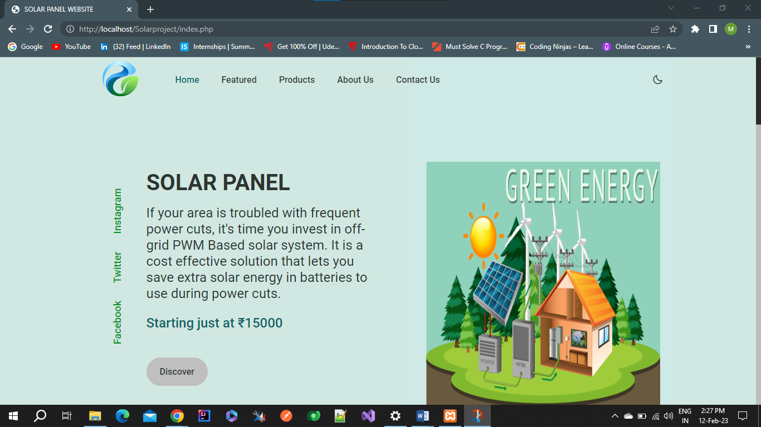

**ABOUT US PAGE**

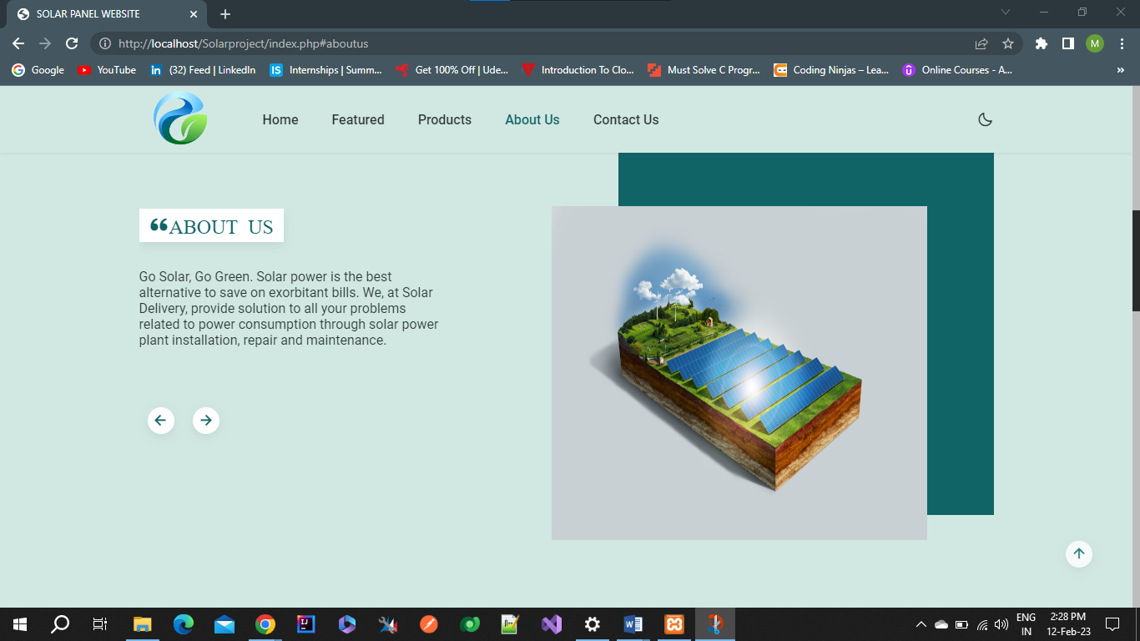

**FEATURED PAGE**

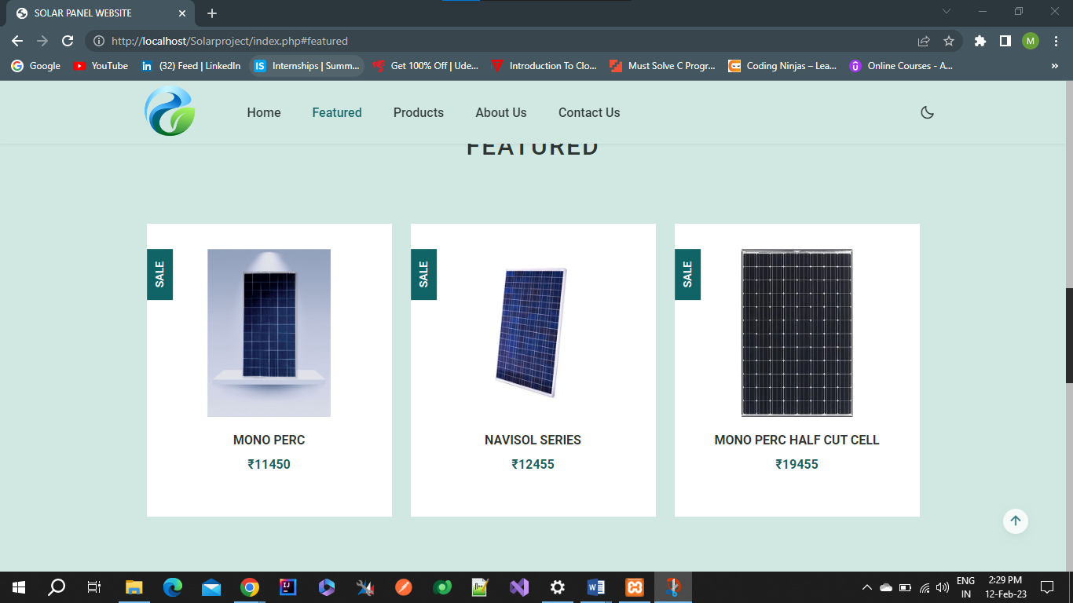

**PRODUCT PAGE**

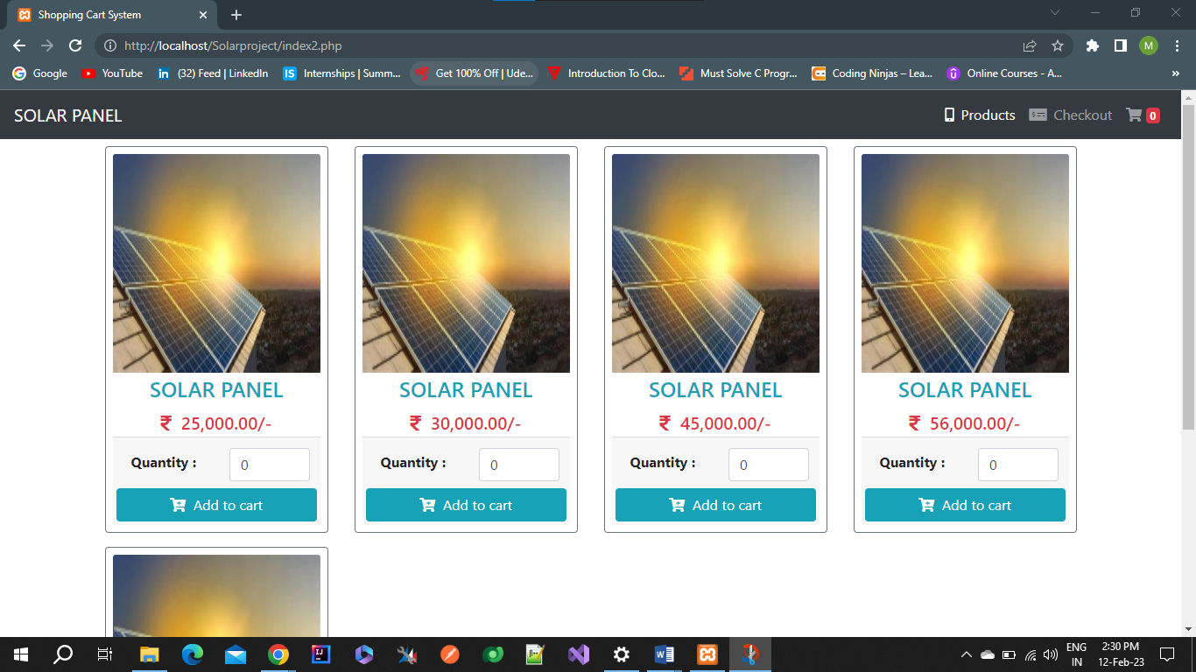

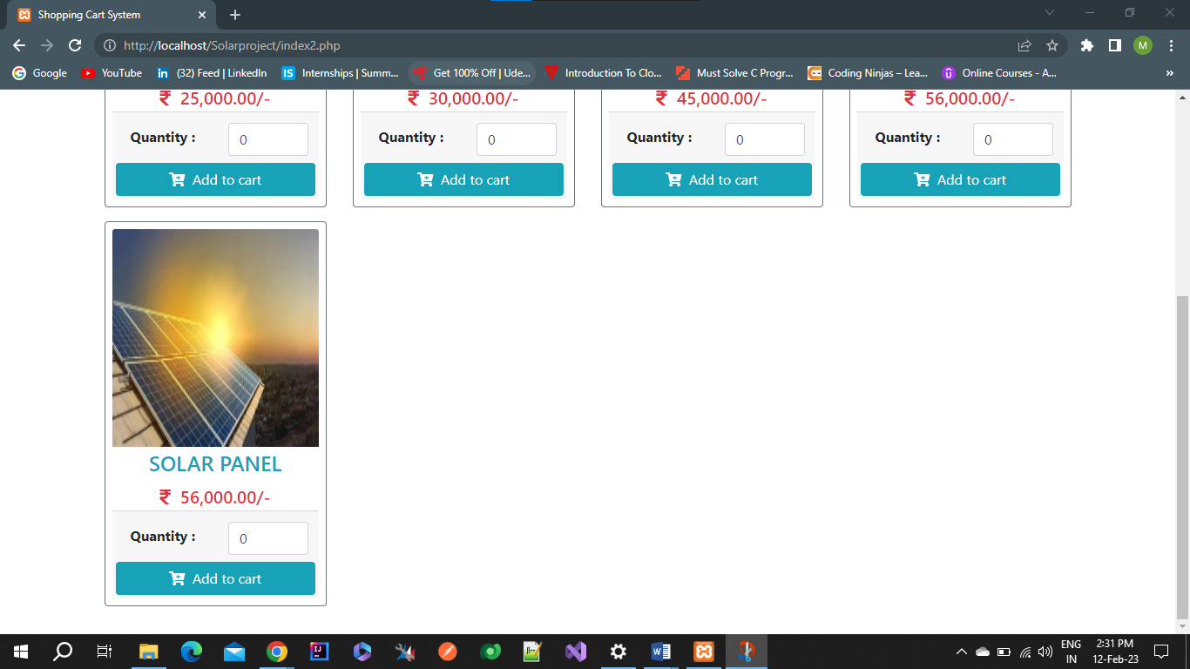

**CART PAGE**

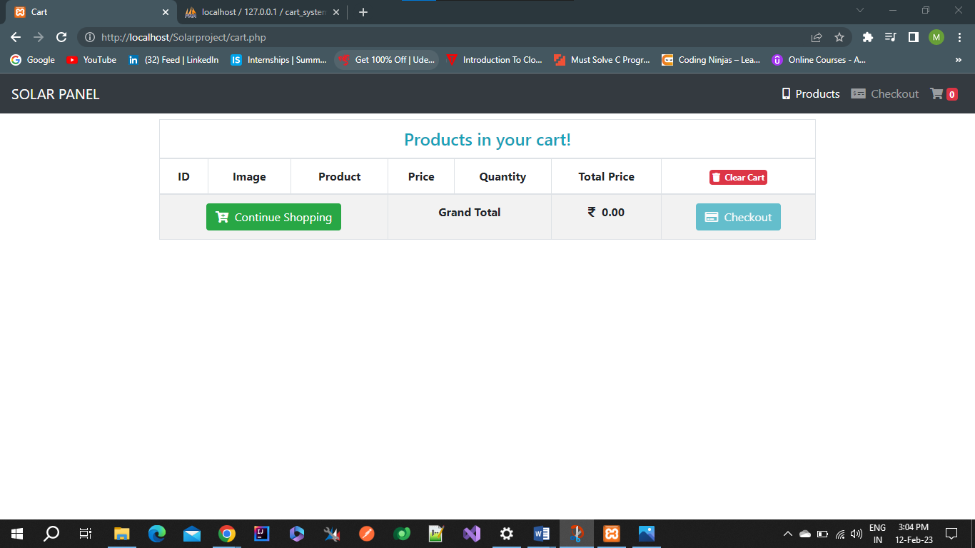

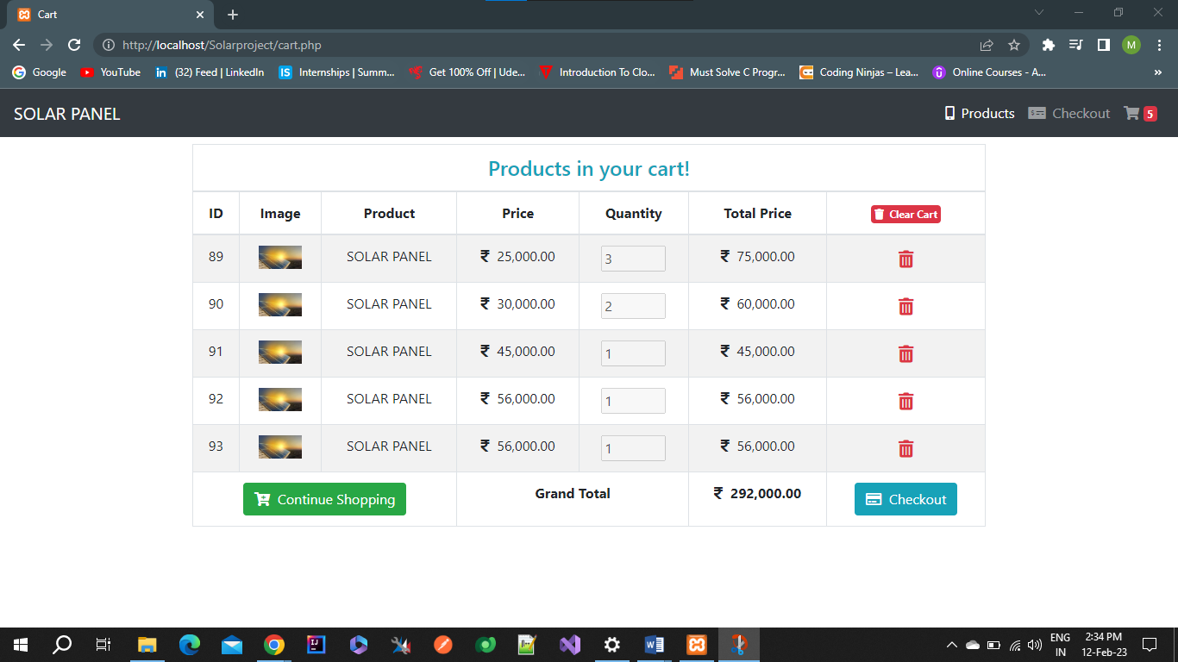

**CHECKOUT PAGE**

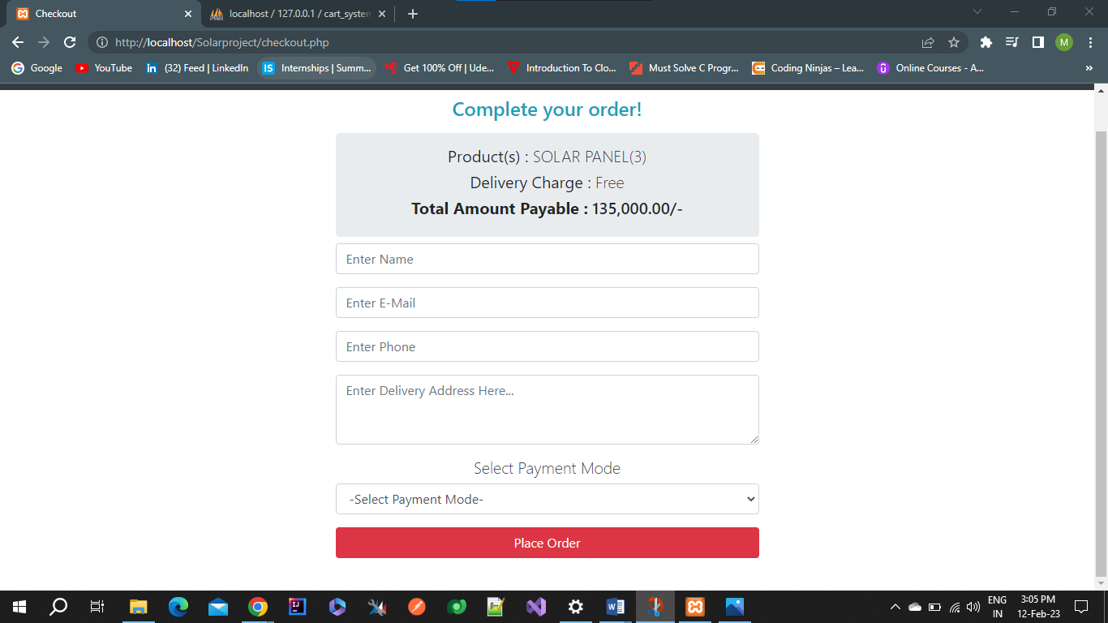

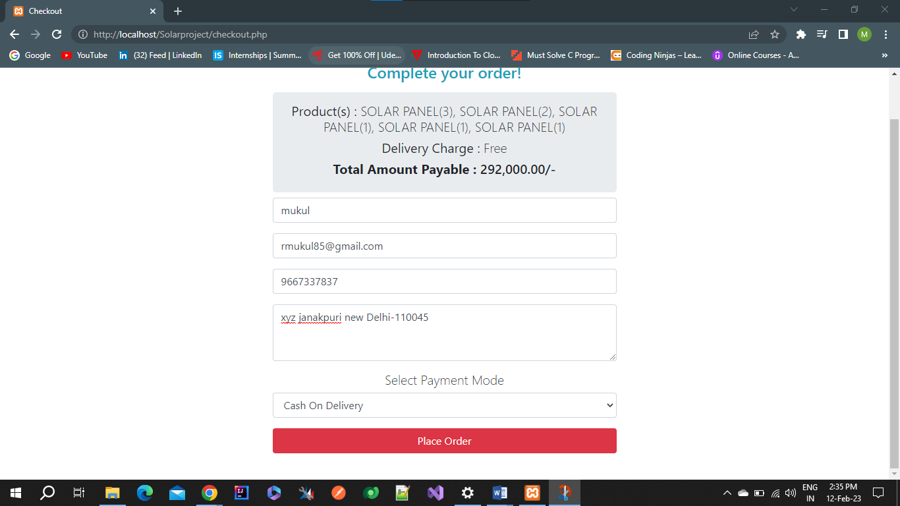

**CONTACT US PAGE**

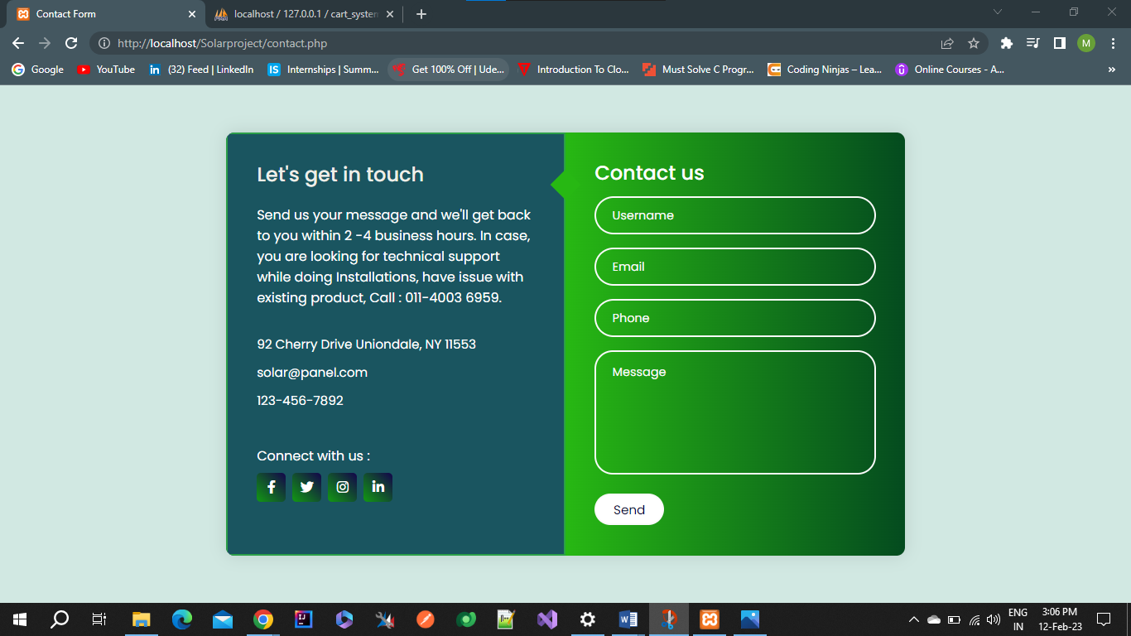

**Database output**

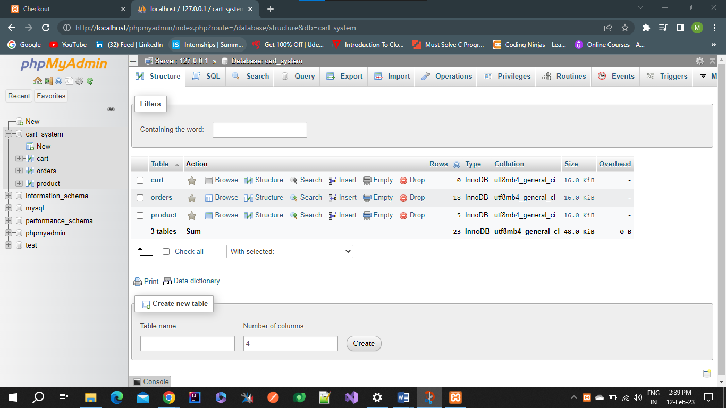

# Chapter 6

## System Testing

The aim of the system testing process was to determine all defects in our project. The program was subjected to a set of test inputs and various observations were made and based on these observations it will be decided whether the program behaves as expected or not. Our Project went through two levels of testing

* + 1. Unit testing
    2. integration testing.
  1. ***Unit Testing***

Unit testing is undertaken when a module has been created and successfully reviewed. In order to test a single module we need to provide a complete environment in besides the module we would require:

* + - The procedures belonging to other modules that the module under test calls.
    - Non local data structures that module accesses.
    - A procedure to call the functions of the module under test with appropriate parameters.

Unit testing was done on each and every module that is described under module description of chapter 4.

1. ***Test for check out page***

Test for checkout page that user can easily add the products in the cart and successfully place the order or not

###### Integration Testing

In this type of testing we test various integration of the project module by providing the input. The primary objective is to test the module interfaces in order to ensure that no errors are occurring when one module invokes the other module.

# Chapter 7

## Conclusion & Future Scope

The **Solar** is a ecommerce website and PHP based project. The main purpose of “Solar” is to sale the solar product to the customers.

In future, we can add the more options such as solar product, payment gateway, user login sign up, product tracking feature and so on. Also for the future we can add the end to end encryption and decryption to make it deployable globally. And also we can add more features.

# Chapter 8

## Reference

* Solar website
* [Google](https://www.google.com/?gws_rd=ssl)
* [Javatpoint - Home](https://www.javatpoint.com/)
* [PHP - Wikipedia](https://en.wikipedia.org/wiki/PHP)
* Text Book – PHP and MySQL
* Text Book - Advanced Web Development